**Second Year Scholarship Application: Cancer Rate Analysis**

1. **Introduction …………………………………………………………………………………………………..…** 2
   1. Introduction of first dataset (Cancer Rate) **………………………………………..………….** 2
   2. Introduction of second dataset (Power Plants) **………………………..……………………** 6
   3. Introduction of third dataset (Super Fund Sites) **…………………..……………………….** 8
2. **Part One: (Analysis of Cancer Rate Dataset) ………………………………………….** 11
   1. Data Cleaning **……………………………………………………………………………………………..** 11
   2. Exploratory Data Analysis **.……………………………………………………………………………** 13
3. **Part Two: (Analysis of Power Plants Dataset) ……………………………………….** 19
   1. Data Cleaning **……………………………………………………………………………………………..** 19
   2. Exploratory Data Analysis **.………………………………………………………………………** 19
4. **Part Three: (Analysis of Superfund toxic waste) …………………………….** 21
   1. Data Cleaning **……………………………………………………………………………………………..** 21
   2. Exploratory Data Analysis **..……………………………………………………………………..** 22
5. **Part four: (Integrated analysis of data sets and predictions) …………….** 26
   1. Exploratory Data Analysis **..……………………………………………………………………..** 26
   2. Prediction Models**…………………..………………………………………………………………** 31
6. **Conclusions ………………………………………………………………………………………………………** 35
7. **References …………………………………………………………………………………** 37

**Introduction:**

Through Internet search, in 2019, nearly 610,000 Americans died of cancer. And there were 1.8 million new cancer patients. Cancer ranks the second in number of deaths among all diseases in the United States, only about 50,000 less than heart disease (National Cancer Institute, “SEER Cancer Statistics Factsheets”). The number of diagnosed cancers continues to maintain at a relatively stable level. Comparing with 2018, the number of men who died of cancer fell by 2%, while the number of women who died of cancer remained the same. But it is important to note that the number of young people in the cancer patients is in an increasing trend in recent years. Cancer is the fourth leading cause of death in the 20-39 age group(American Cancer Society, “Key Statistics for Cancers in Young Adults”). The reason behind this phenomenon may be obesity, or excessive drinking (Piersol). So, as a person in this age group, I want to study some information behind cancer.

More than a century ago, scientists predicted that a cure for cancer was just five years away. However, with the development of medical technology, it is still difficult to conquer cancer. This is inseparable from the nature of cancer cells, which are different from each other and have the ability to mutate their way out of the immune system.

Still, people can try to reduce their risk of cancer in other ways. For example, the energy types used by power plants in the following three data sets, as well as the EPA's superfund site policy, will produce different substances when different energy sources are used for power generation. For example, burning coal will generate sulfur and carbon monoxide, which will increase the risk of cancer to the residents near the power station.

Before going into the report, let me introduce the three data sets I used.

**the First Dataset: (Data For Cancer Rate)**

The name of the first data set is USA_CancerRates_All_ByCounty, which has 2932 rows and 10 columns.

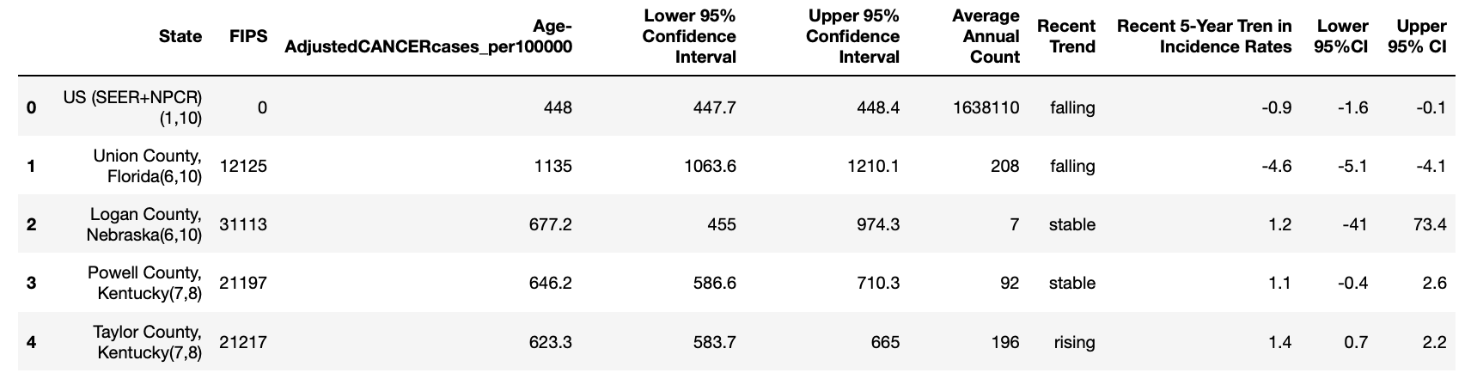

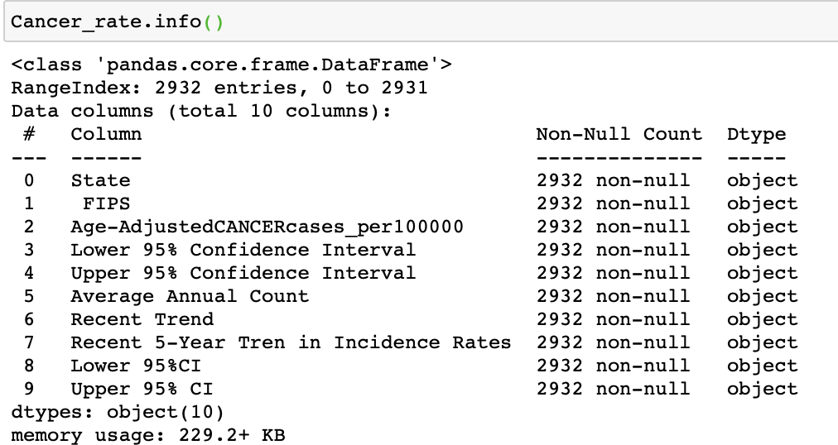

**State:**

The first column contains the geographic information, including the name of the state and the county, with the number of SEER and NPCR after the name of the state. Let me start by explaining what SEER and NPCR stands for.

**NPCR** (National Program of Cancer Registries): The number of registries

By comparing the explanation on the internet with this first dataset, I found that the number of NPCR represents the number of Registries. In 1994, 37 programs began receiving funds during the project's first 5-year period. In 1995, it was 27. And in 1996, seven programs were added. this graph will help us to understand better.

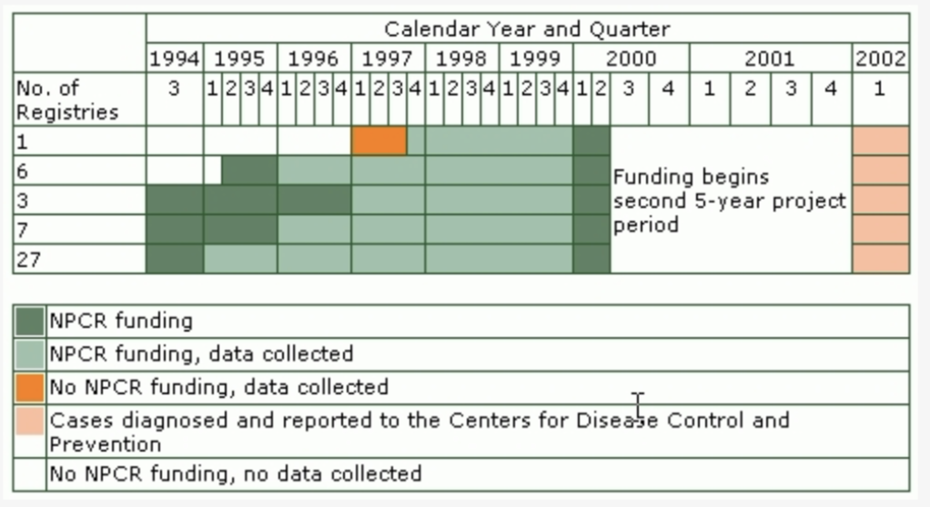

The different colors in the figure below represent different NPCR values. (American Cancer Society, “The Value of Cancer Registries to the Public’s Health” 2)

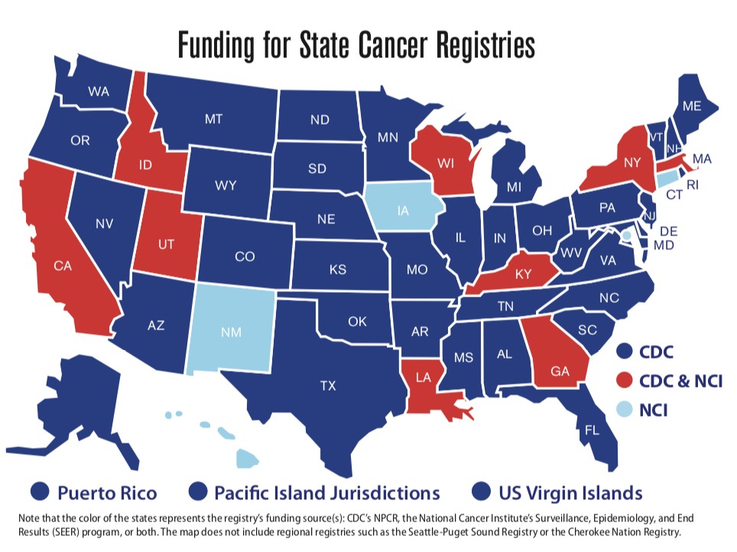

**SEER** (Surveillance, Epidemiology, and End Results):

I'm going to introduce SEER which is a project that works with NPCR. The combination of SEER registries has several ones respectively. SEER 9 represents the available cases diagnosed from 1975 through the current data year, and SEER 13 represents the data collected started from 1992. And the data contained in the expanded RACES, SEER 18 represents the data collected from 2000. It also includes data for expanded RACES, and the last one is SEER 21. (American Cancer Society, “Cancer Facts & Figures 2019” 70)

**age-adjustedcancercases_per100000**:

The next column is age-adjustedcancercases_per100000. It seems difficult to understand the meaning of age-adjusted, so I searched the information online. Another term for age-adjusted is age-standardization. The reason for this method is to study the prevalence in different populations. Therefore, we can interpret this column as the number of cancer patients per 100,000 people after applying age-standardization. The two columns immediately following this column represent the upper and lower bound of this value.

The next four columns describe trends in the number of cancer patients. They are Recent Trend, Recent 5-year Trend in Incidence Rates, and the lower and upper bound of Recent 5-year Trend in Incidence Rates.

**Recent 5-year Trend in Incidence Rates**:

The incidence rate is based on 100000 people annually.

**Lower 95%CI & Upper 95%CI**: (National Cancer Institute, “Interpretation of Incidence Rates Data”)

The calculation method of the upper and lower ranges of Recent 5-year Trend in Incidence Rates was mainly based on AAPC (which means Average Annual Percent Change calculated by Joinpoint Regression Program) and APC (which stands for Annual Percent Change calculated by SEER).

**Recent Trend:**

Recent Trend is a categorical column with three values: falling, rising and stable. The value of these values is conditional on the upper and lower range of Recent 5-year Trend in incidence rate. If the range is greater than 0, the value of rising will be assigned; if the range is greater than 0, the value of stable will be assigned; if the range is less than 0, the value of falling will be assigned.

Then, I will illustrate the second dataset.

**the Second Dataset: (Data for Power Plants)**

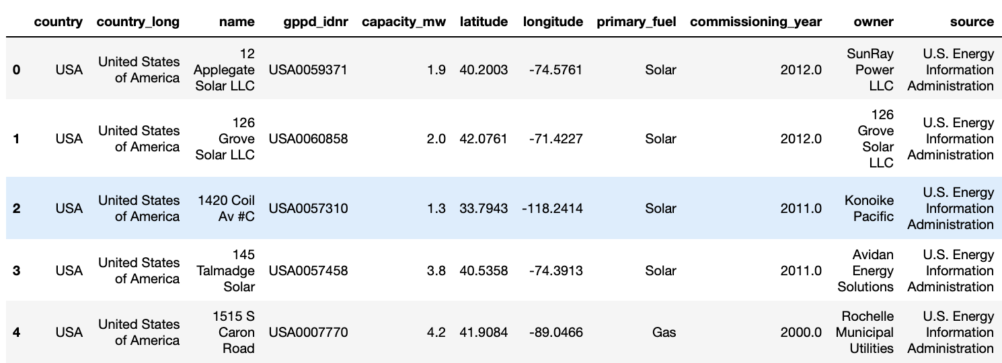

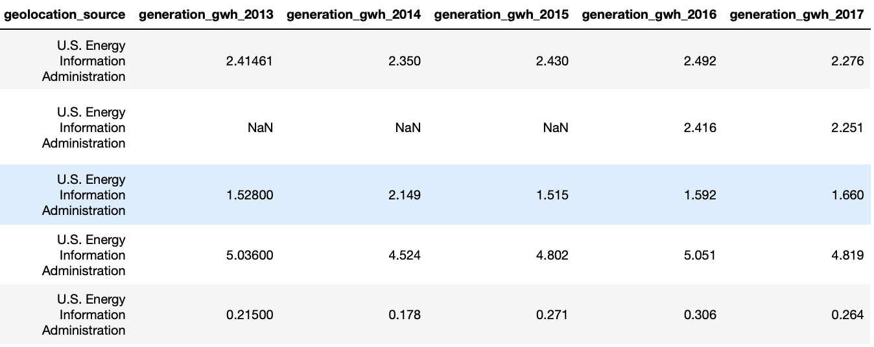

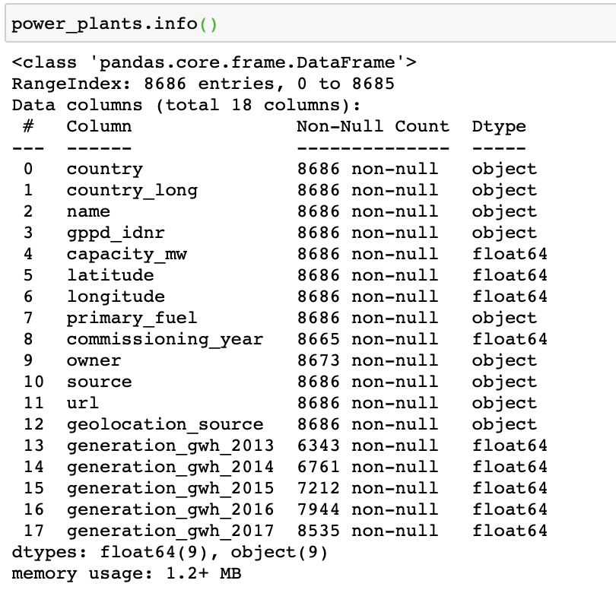

This data set has 8686 lines and 18 columns.

**Country, country_long: (The geographical position)**

We only have data in USA (United States of America).

**Name:**

The name of this power plant.

**gppd_idnr:**

10 or 12 character identifiers for the power plant.

**capacity_mw: (Kirpal)**

The electrical generating capacity in megawatts.

**Latitude, Longitude:**

The geolocation of this power plant.

**primary_fuel:**

The primary energy source used in electricity generation or export.

**commissioning_year:**

The starting time of the power plant. And it will be adjusted according to the time when the data is available.

**owner:**

The majority shareholder of the power plant.

**source, geolocation_source: (Kirpal)**

The entity which reports this data.

In this dataset, we have only one entity, which is U.S. Energy Information Administration.

**generation_gwh_2013 – generation_gwh_2017: (Kirpal)**

The electricity generation in gigawatt-hours in each year.

**The Third Dataset: (Data for** **Super fund toxic waste sites):**

**The third data set is about super fund site data. But the given Excel file only contains a web page. After I opened the website, I found there are several buttons in each row, such as Site Listing Narrative, Site Progress Profile, and Federal Register Notice.**

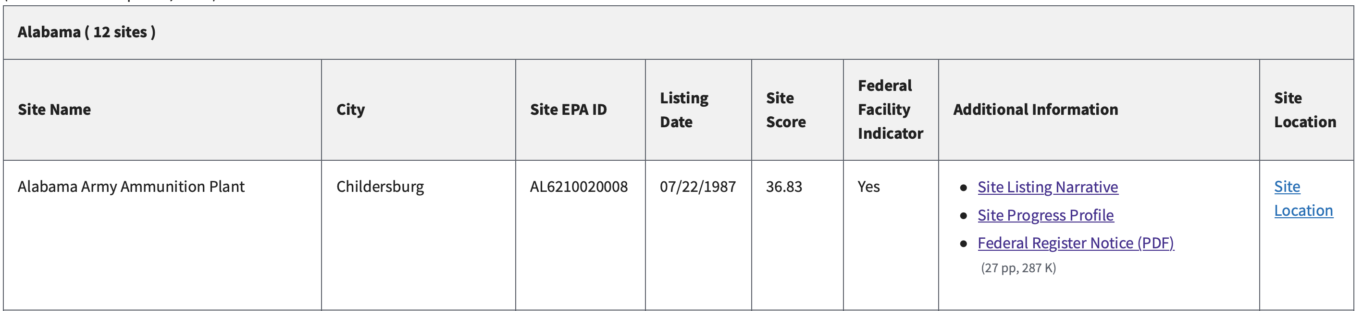

Meanwhile, at the right side of these options, I found a button called Site Location options. After clicking this button, a new web page will show more detailed information, such as the latitude and longitude. So, I'm going to use python for web scraping on the web page.

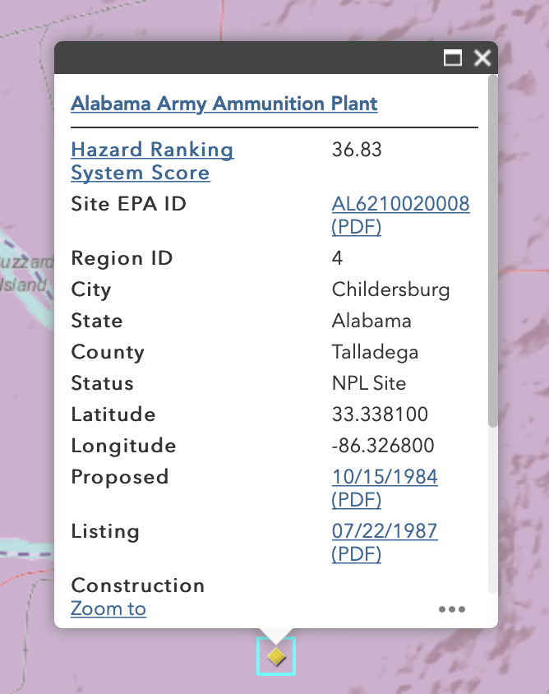

I first tried to scrap the new web page above, and all the information I needed was in this kind of popup rectangle. Although the useful information is all showed on the safari after using Inspect Element, when I used Beautiful Soup and request packages to get this web page’s information, the classes of hidden popup that contain the information I need did not appear. Then, I thought it's probably because the information was stored in this hidden popup, so Beautiful Soup can't get it.

So, I changed my mind. I decided to web scrap the web page in the Excel directly. After clicking Inspect Element, I clicked Network and tried to find the page that stores all the information on the left through multiple refreshes. Finally, I found a file named nplfin.xml, which contained the information I was looking for. So, I did a bunch of things, and I got the following data set.

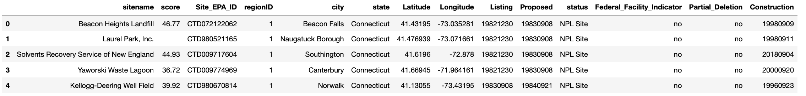

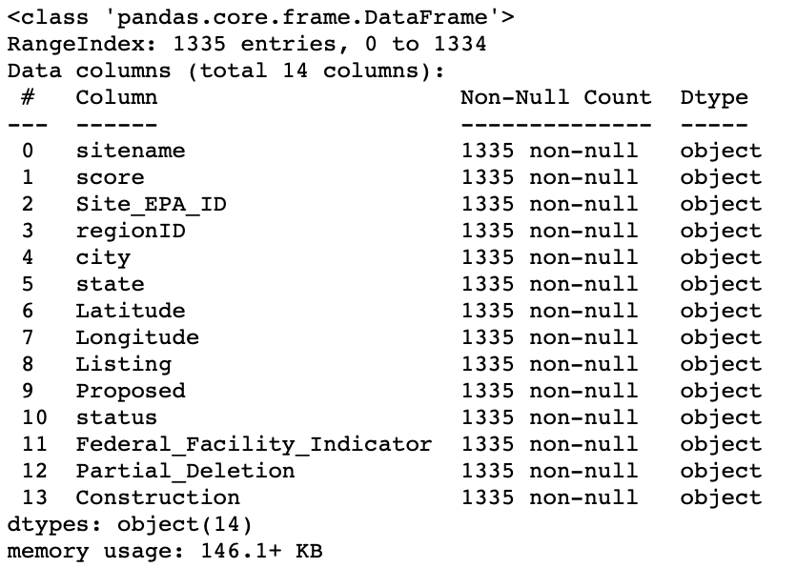

This new dataset has 1335 rows and 14 columns. Let me introduce each column’s meaning.

**sitename:**

Super fund toxic waste sites’ name.

**Score:**

This score is determined by Hazard Ranking System, and it is aimed to assess the sites’ relative potential threat to human health or the environment. This ranking system will evaluate the characteristics of the waste, ground water migration, and so on. (United States Environmental Protection Agency, “Introduction to the Hazard Ranking System”)

**Site_EPA_ID:**

Each site’s ID.

**regionID:**

This web page divides the United States into 10 different regions, and each number represents a different region.

**city, state, Latitude, Longitude:**

The site’s geolocation.

**Listing:**

When EPA selected this site to the NPL (National Priorities List).

**Proposed:**

When EPA's second update of the NPL.

**Status:**

Whether the site is NPL site or not.

**Federal_Facility_Indicator:**

An indicator identifying facilities owned or operated by a federal governmental unit (United States Environmental Protection Agency, “Facility Site Identification Data Standard” 6).

**Partial_Deletion:**

whether allows EPA to delete releases at portions of NPL sites (United States Environmental Protection Agency, “Notice of Policy Change for Partial Deletion from the NPL”).

**Construction:**

When the site has achieved the construction requirements.

**Part One: (Analysis of Cancer Rate Dataset)**

1. Data Cleaning

The first step I choose is to check whether there are missing values in this dataset. The result is this dataset is relatively clean with no null values.

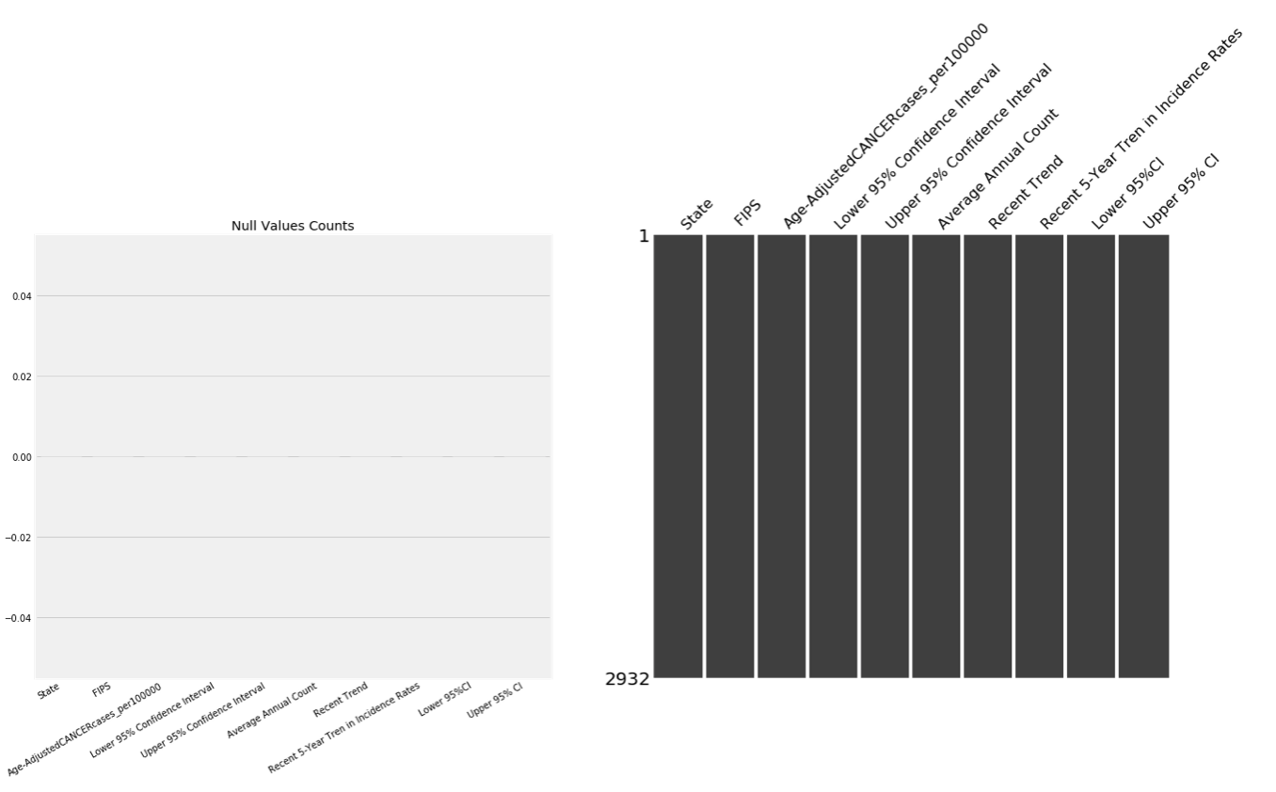

As I said above, the first column has a lot of information stacked together. What I'm going to do is break down the first column into four columns: state, county, SEER, and NPCR.

In this process, I found that some rows have special places, which did not belong to the state, nor to the county. I first screened these areas, which are the first row representing the total number of US, Washington DC and Puerto Rico. Meanwhile, there were some states without NPCR data, so I chose to use 0 to fill them.

The result is:

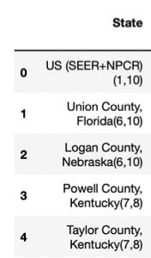 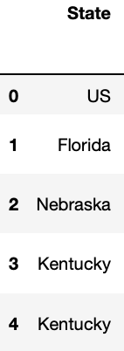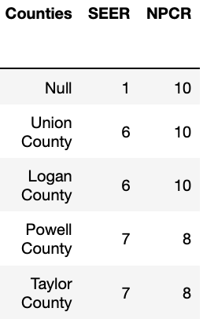

Before I do the analysis by plotting graphs, I also need to make sure that all columns with type float or int are numbers, and that columns whose types are object only contain valid words.

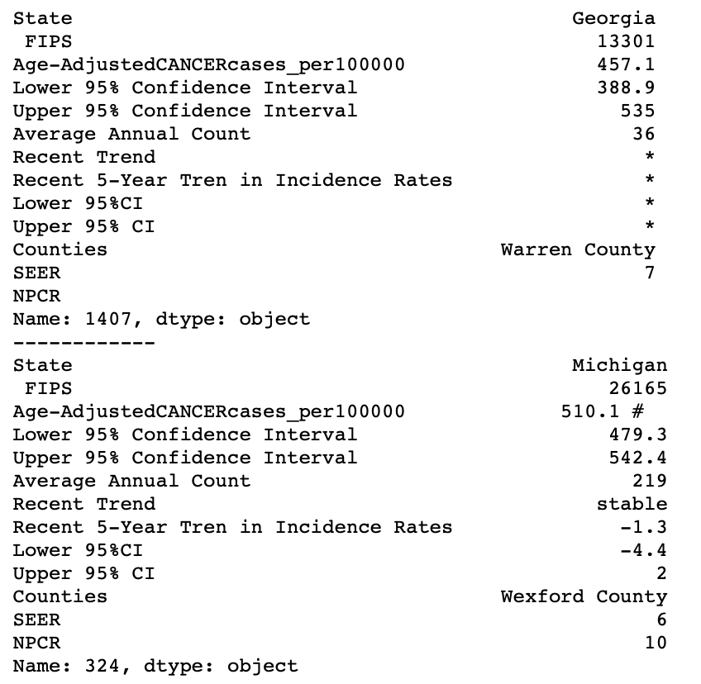

So, I further cleaned lots of these categories of data. I chose to deleted value with symbols like ‘#’ and dropped the rows which has '*'.

1. Exploratory Data Analysis

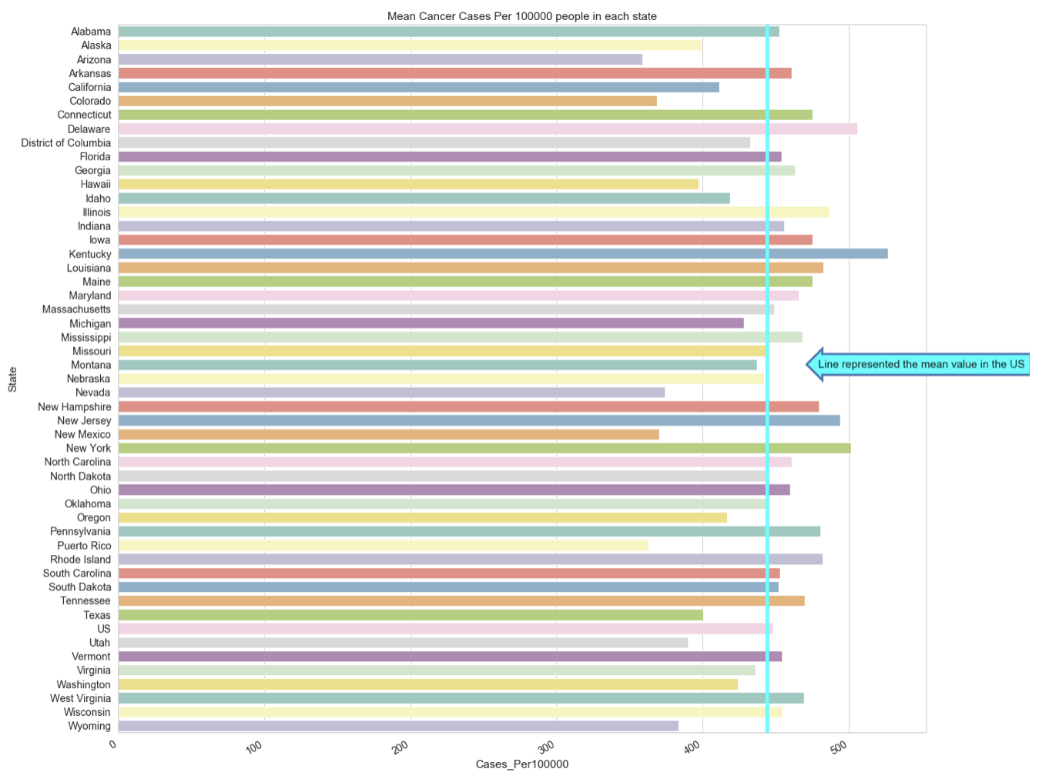

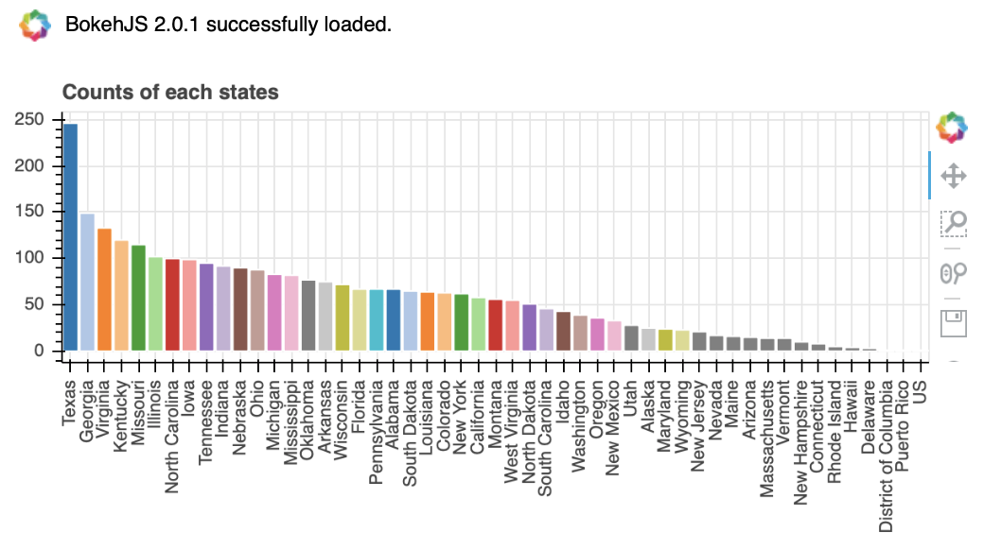

It is not hard to find that most of the states are near the national average, but each state has a different number of data. Texas has nearly 250 pieces of data about its counties, but some states have only fewer than ten pieces of data.

Then, I decided to analyze the dataset according to the variable "recent trend". According to the data set, there are only a few counties with a rising trend in the five-years-period. Therefore, in the last column(rising_or_not), yellow represents that there is no county in this state with a rising trend in incidence rate of cancer. However, if the color is green in this column, it means that there is at least one county with an upward trend.

The next to last column is the column of "falling - stable". I decided to find the states with a relatively high proportion of counties having a declining trend.

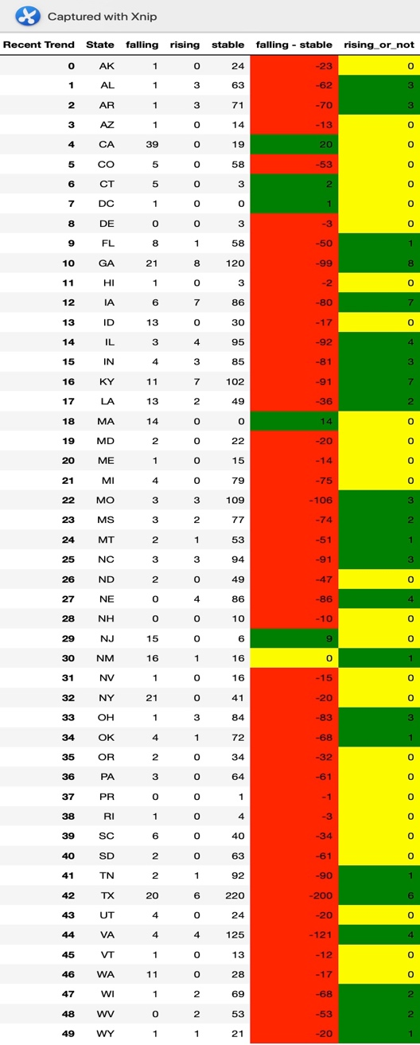

In the next step, I first selected the states with data samples greater than 40. Among them, I selected three states with the highest average cancer cases per 100,000 people and three states with the lowest average values for analysis.

|  |  |
| --- | --- |
| States | Mean value of cancer cases per 100000 people |
| Kentucky | 526.52 |
| New York | 501.57 |
| Illinois | 486.33 |
| Colorado | 368.45 |
| Texas | 400.55 |
| California | 411.40 |

If we plot the two key data points, cases_per100,000 and trend_in_5_years, we can find that the data of three states with the highest average number of cases, that is, the enclosed area, are gathered in the center of the image. Therefore, the number of cancer cases per 100,000 people has little relationship with the trend of the individual counties in the state.

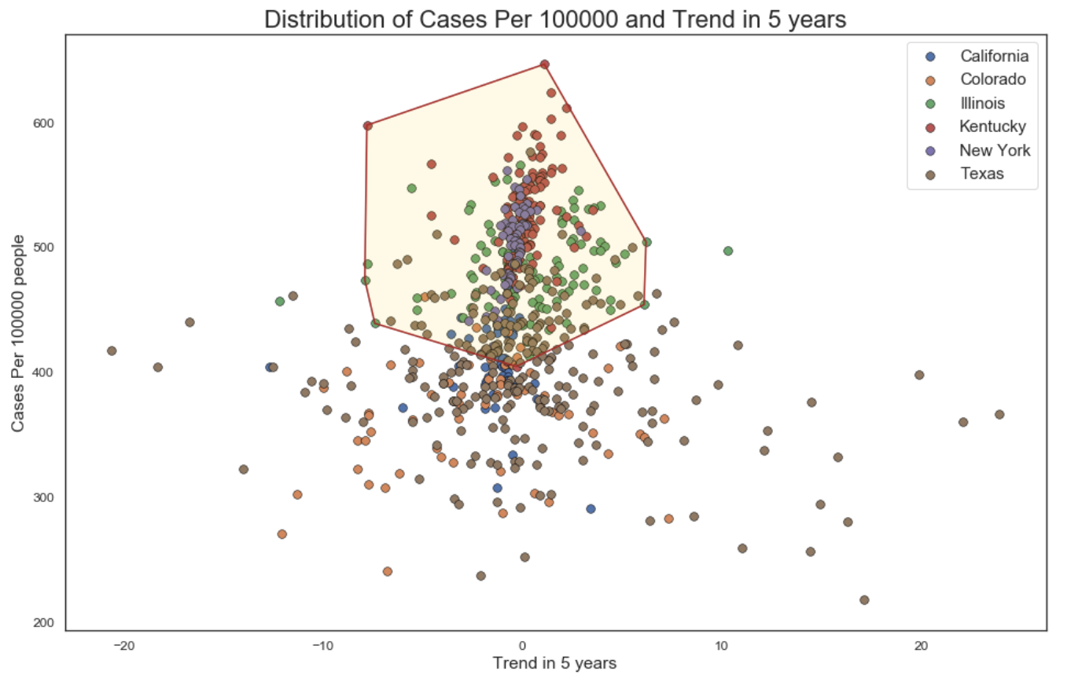

At the same time, from the scatter distribution on the image above, it is not difficult to find that most of the points in six states are clustered in the middle of the image. And there are also some scattered points on the left and right side of the image respectively. So, I decided to draw the distribution plot of cases_per_100000 in these six states to confirm whether their data samples conform to normal distribution.

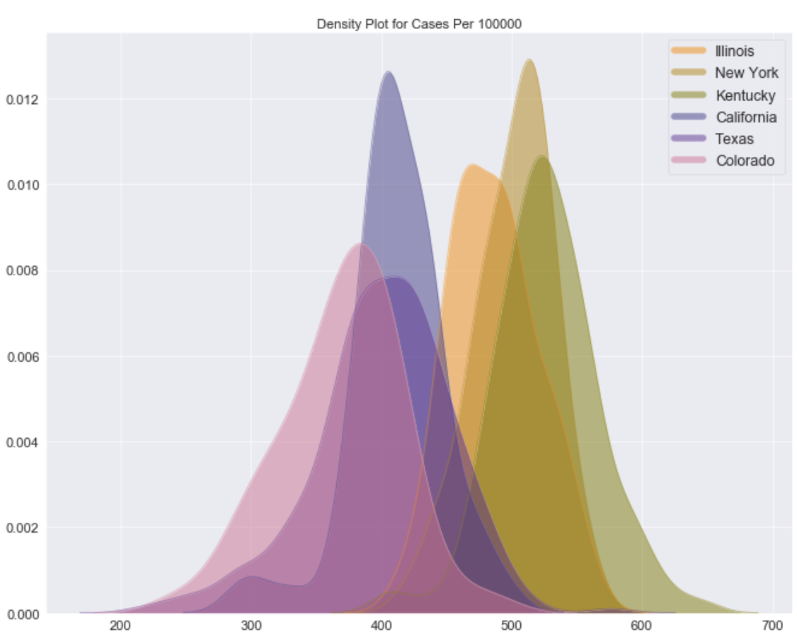

After drawing the distribution of them, they appear to be normal distribution roughly.

Since the data set has trend_in_5_year's lower and upper bound, and cases_per_100,000's lower and upper bound, I decided to plot the bar plots of these two variables and plotted the error bars based on each upper and lower bound.

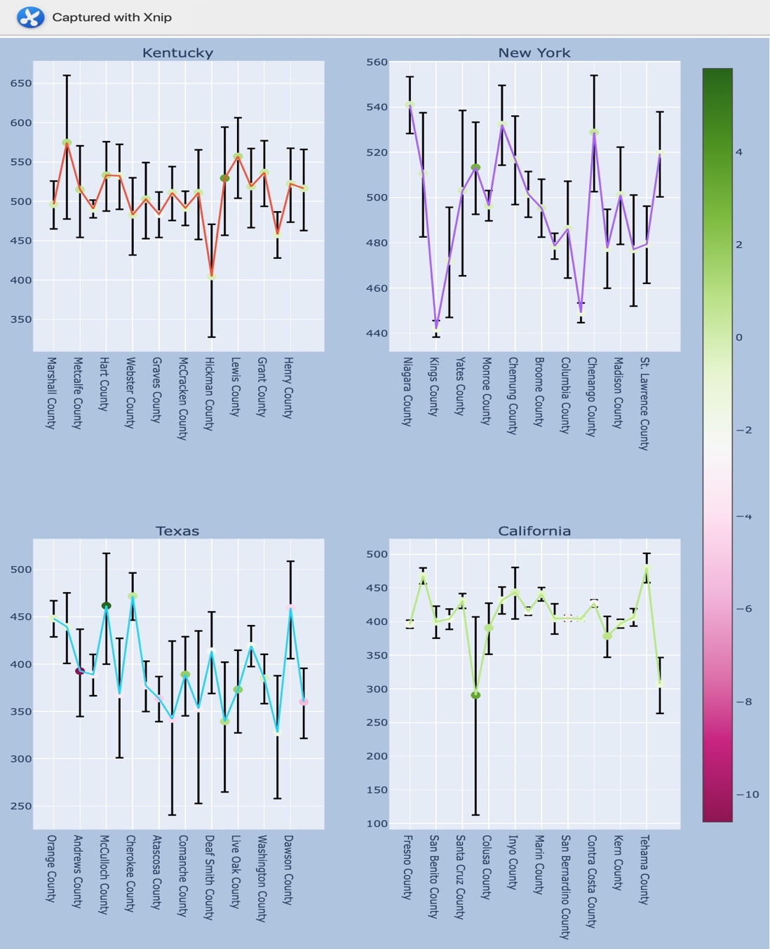

The first picture illustrates the cancer cases per 100,000 people in the four selected states. In order to facilitate observation, I randomly selected 10 samples from each state to make the picture. It can be found from the picture that the error bars in Texas have a large interval, while most counties in California have a small confidence interval. Second, we can find that the data of New York county varies a lot.

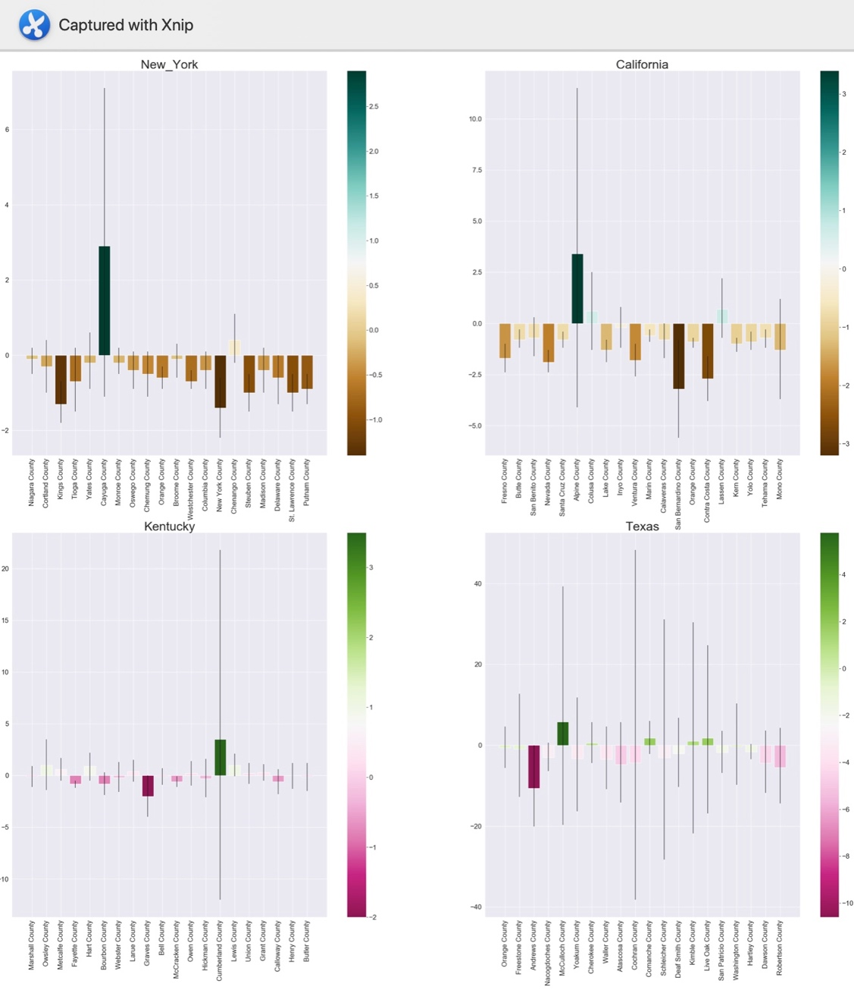

The second drawing is about trend_in_5_years. The characteristics of this drawing are basically the same as the one above. Texas still has a very wide confidence interval in each county, and three other states have relatively small confidence intervals comparing with Texas. And we can see that New York has most of the counties that has drastic falling trend.

**Part Two: (Analysis of Power Plants Dataset)**

1. Data Cleaning

For this dataset, the only thing I need to deal with is null values in the several columns about electricity generation. After searching information online, I decided to fill them by 0.

1. Exploratory Data Analysis

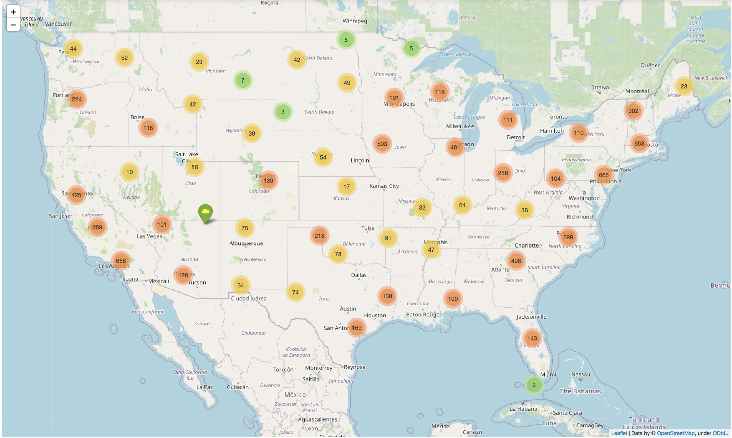

First, I used folium to draw the distribution of power plants in various regions according to latitude and longitude. You can roughly see that each state has a different number of power plants, and each popup contains this power plant’s information.

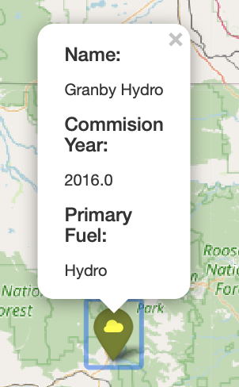

At the same time, in order to further visualize the change of electricity generation of each power plant from 2013 to 2017, I drew the second folium diagram. When popup is clicked, the bar plot of the electricity generation of this power plant in the past five years will appear.

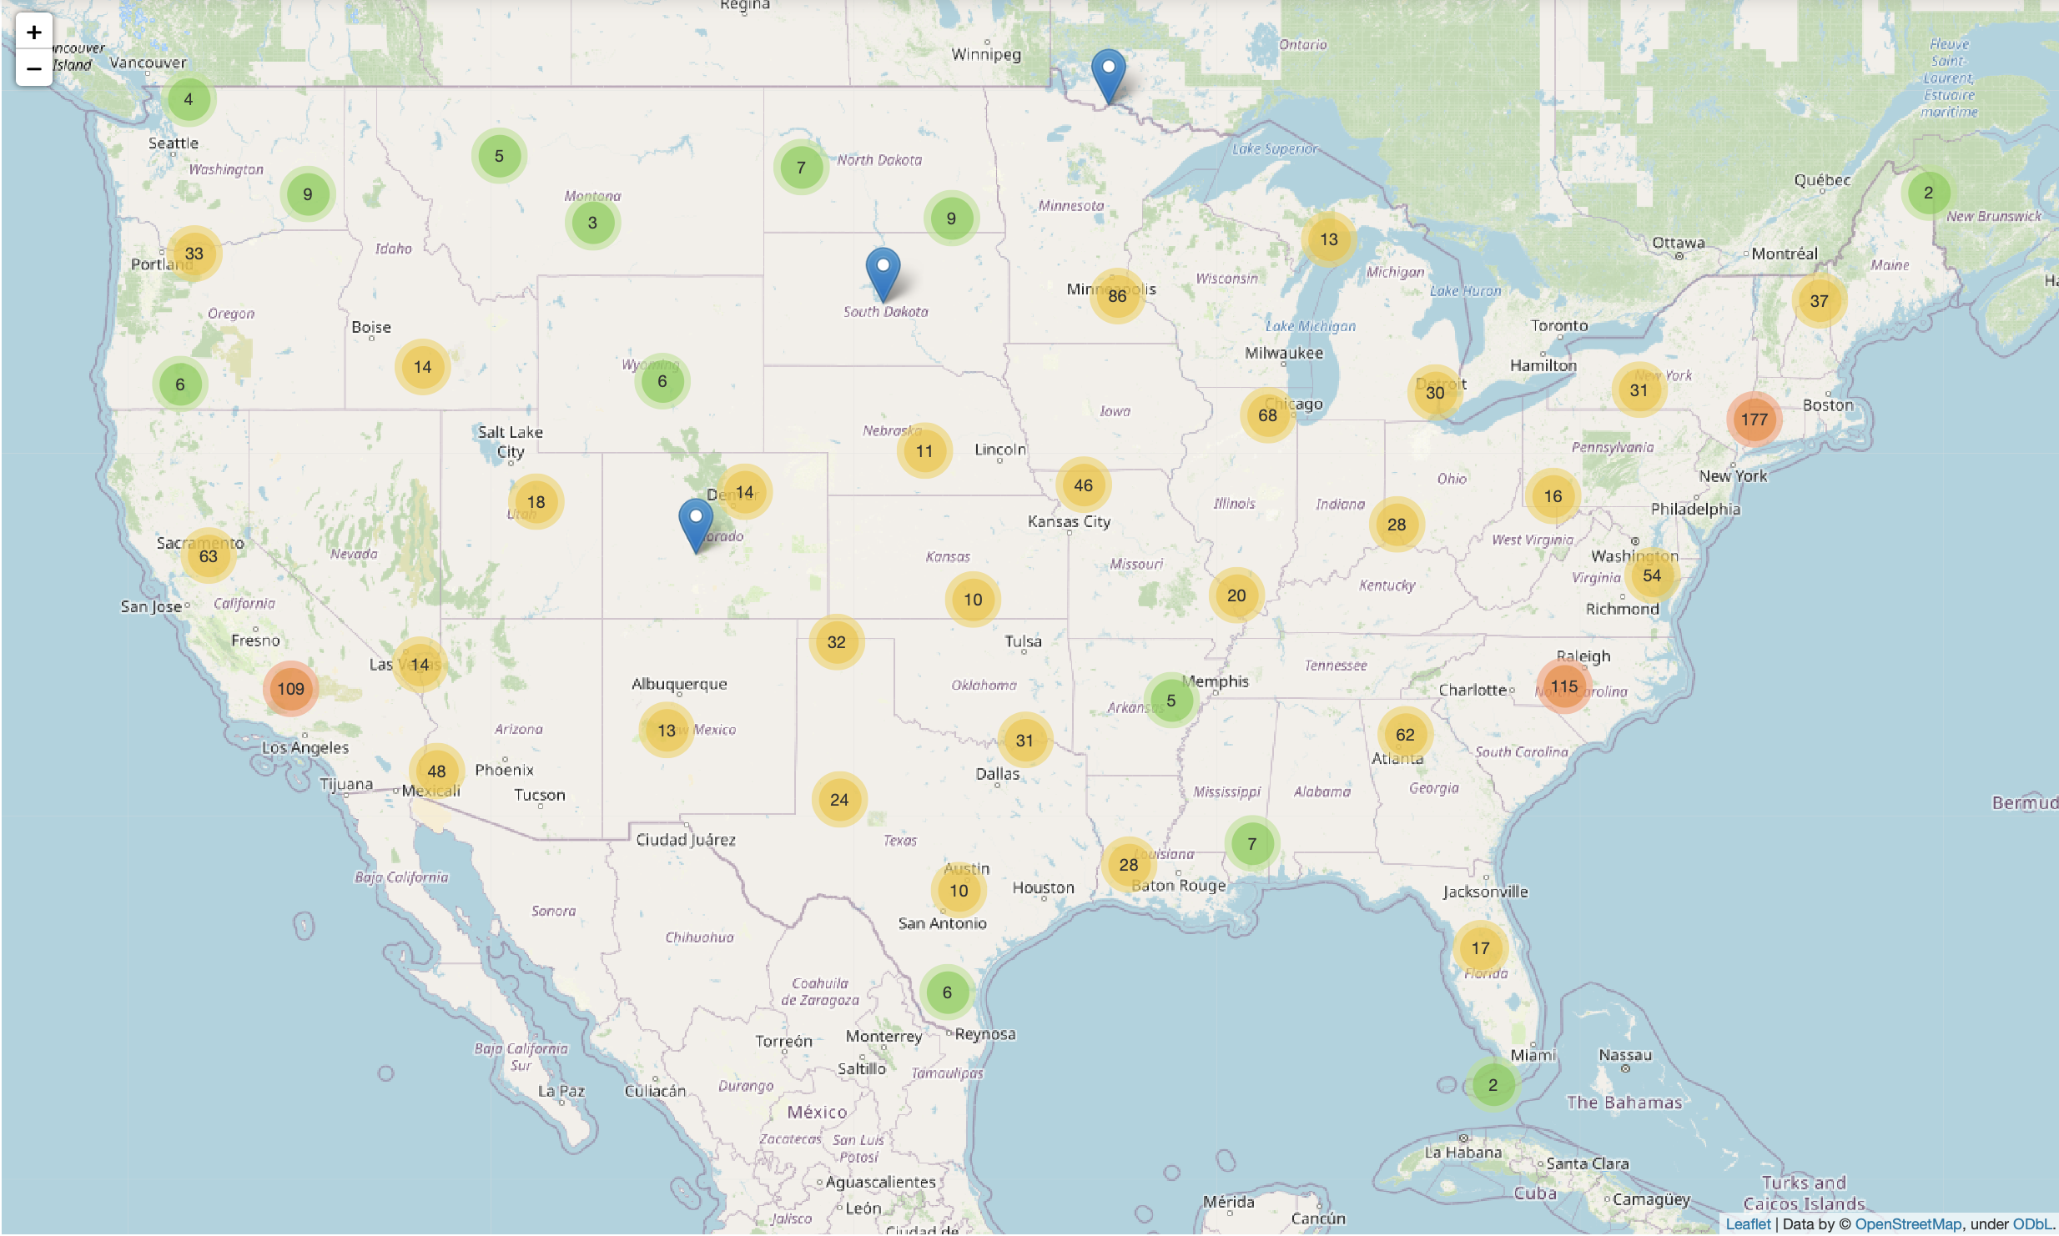

Due to the limited memory of my computer, I was unable to show more than 9000 bar plots. So I only randomly selected 40% of the data to show them. Therefore, the figures in this diagram are different from those in the previous one.

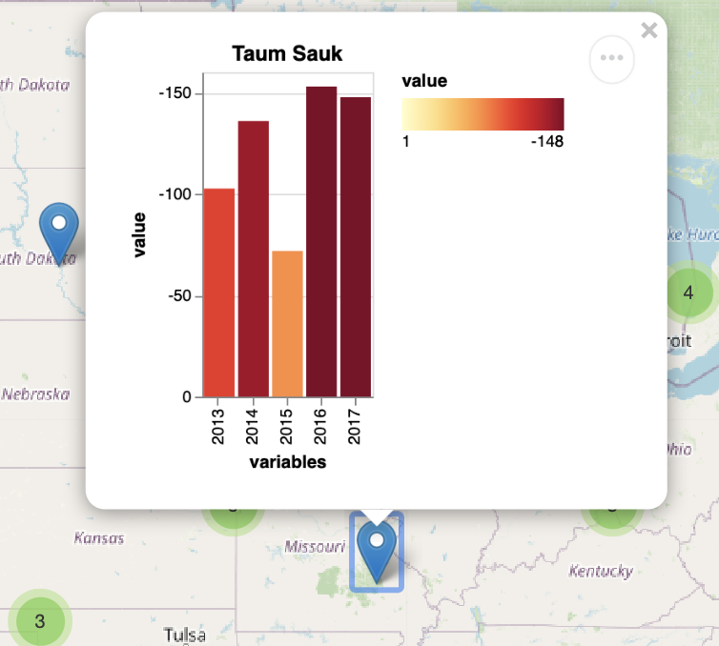

Pushing each popup icon will show the power generation trend of each power plant over the five years.

In part four, I will combine this data set with the other two data sets for further analysis.

**Part Three: (Analysis of Superfund Super fund toxic waste sites)**

1. Data Cleaning

This data set is also relatively clean. The first thing I found that is column Construction contains some empty data, and then I filled them with 0. I also found that columns Construction and Listing and Proposed columns mixed year, month and day together. Therefore, I split them into year, month and day of three different columns, which means a total of nine new columns.

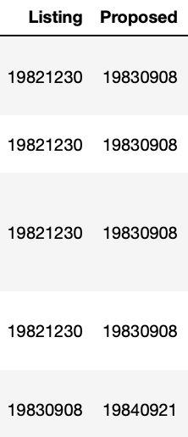 

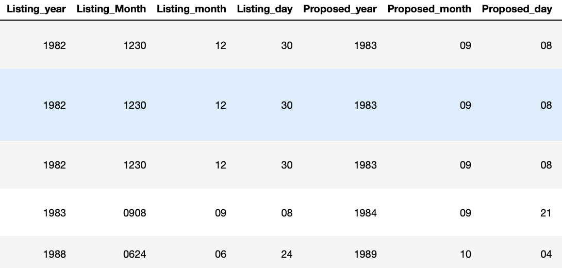

1. Exploratory Data Analysis

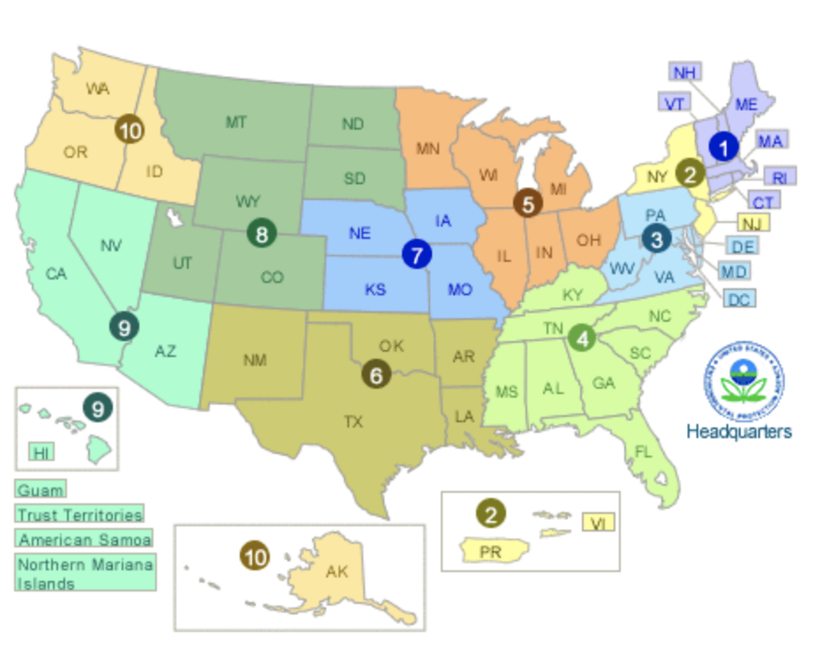

(United States Environmental Protection Agency, “Visiting a Regional Office”)

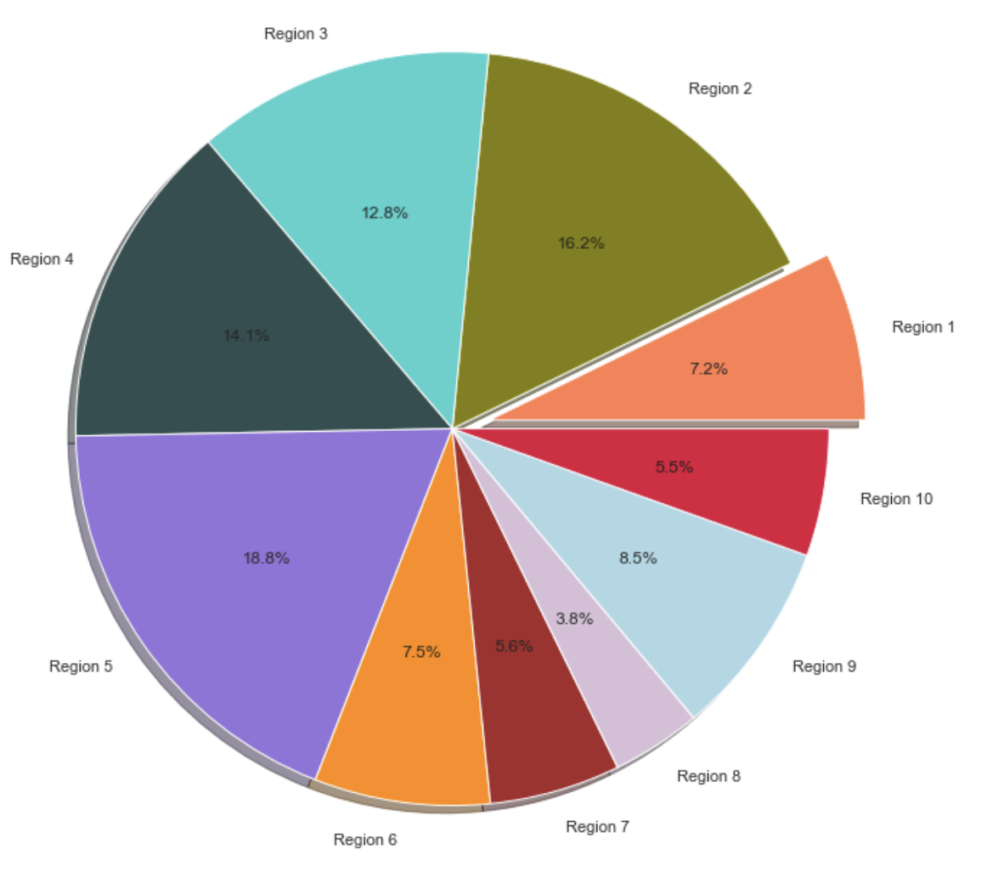

I divided the regions according to region ID, and it can be seen that the number of superfund sites in each region of the United States is quite different. Some regions occupy nearly 20% of superfund sites, while some regions occupy less than 5%.

In this data set, the score is definitely an important variable. I'm going to put it as target variable. Among my personal impression, unified management by the government organizations are likely to become more disciplined, so I think there is possible link between the score and Federal_Facility_Indicator. At the same time, if there is a site with partial deletion, the reason may be that the score is not up to standard. Thus, this variable may be also related to the score. So I drew box plot and distribution plots for them below.

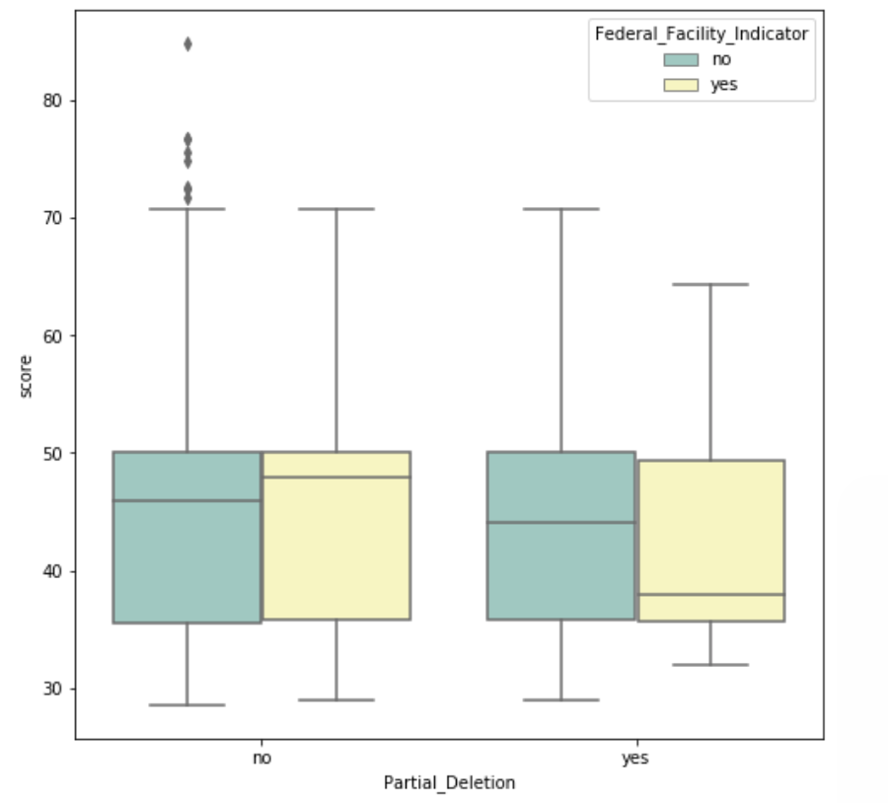

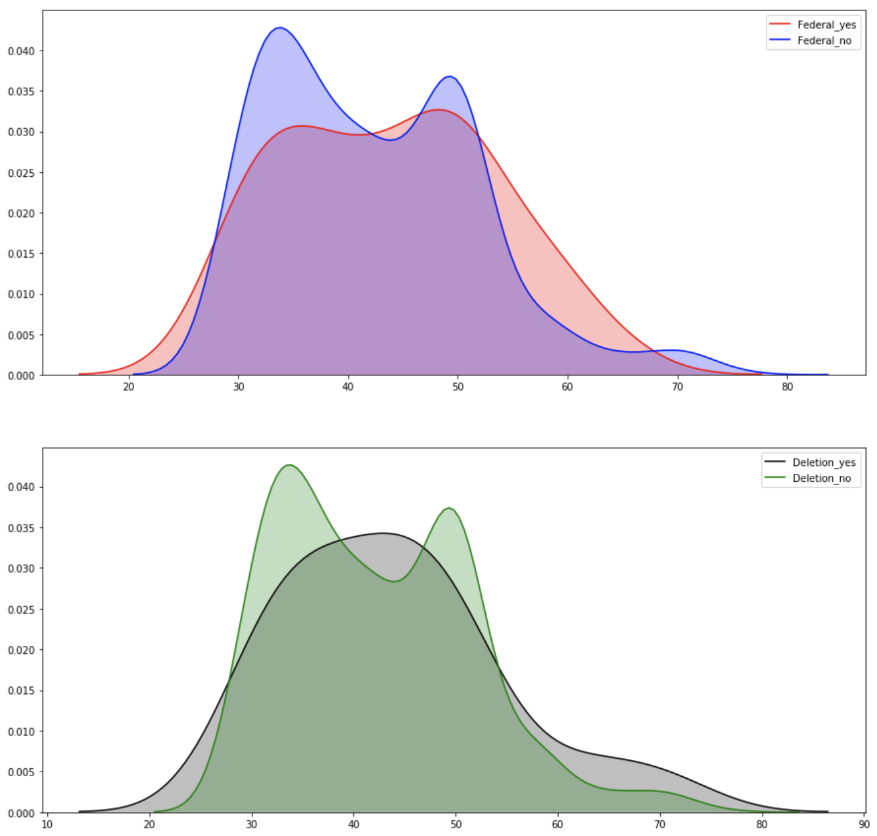

It can be seen from the above figure that partial_deletion and federal_facility_indicator have limited influence on score. In the box plot of the first graph, the data of federal_facility_indicator will affect the mean value of score only if partial_deletion is yes. However, from the next distribution plot, these two variables are not related to the score. But I also found out that when federal_facility_indicator was equal to yes and when partial_deletion was also equal to yes; their distributions were exactly the same.

In order to explain why these two variables are not related to score, I searched online for relevant information.

Reasons why federal_facility_indicator and score are irrelevant:

1. Comprehensive Environmental Response, Compensation, and Liability Act (CERCLA)

CERCLA§120 discusses the applicability of CERCLA to federally owned or federally operated facilities. Section 120 provides for the general principle that federal agencies must comply with CERCLA's substantive and procedural requirements to the same extent as private entities and assume the same responsibilities.

Therefore, there is no difference between the industry standard of federal utility and private utilities, which may also result in the variable’s independency of score. (United States Environmental Protection Agency, “Comprehensive Environmental Response”)

Reasons why Partial_Deletion and score are irrelevant:

1. An important criterion for partial_deletion is the HRS score. Sites with an HRS score of 28.5 or higher are eligible for NPL, but all sites in the data set have a score greater than 28.5 (United States Environmental Protection Agency, “National Oil and Hazardous Substances Pollution Contingency Plan” 1).
2. Some sites that have partial_deletion may be removed from the NPL once all response actions have been completed and all cleanup goals have been achieved.
3. The inclusion of a site on the NPL does not itself represents a judgment on the activities of its owner or operator. The NPL is primarily used to provide information and is intended to identify for the state and the public what remedial action may be required.

Therefore, in order to further find variables related to the score, I drew a correlation plot with different colors represented different correlations.

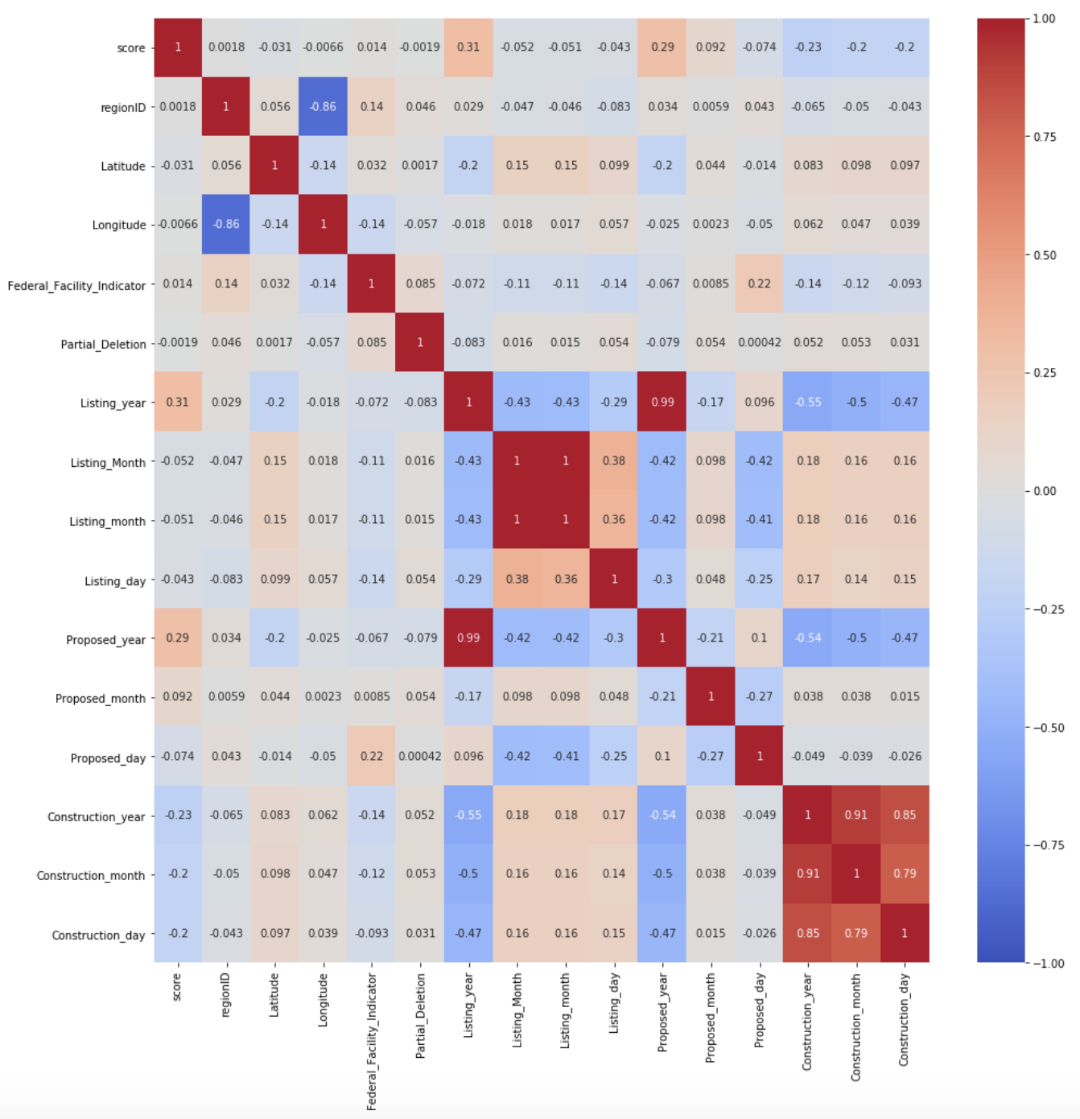

From this heatmap, it is not difficult to find that the two variables most closely related to score are Listing_year and Proposed_year. Therefore, we will draw the line plots for score based on these two variables.

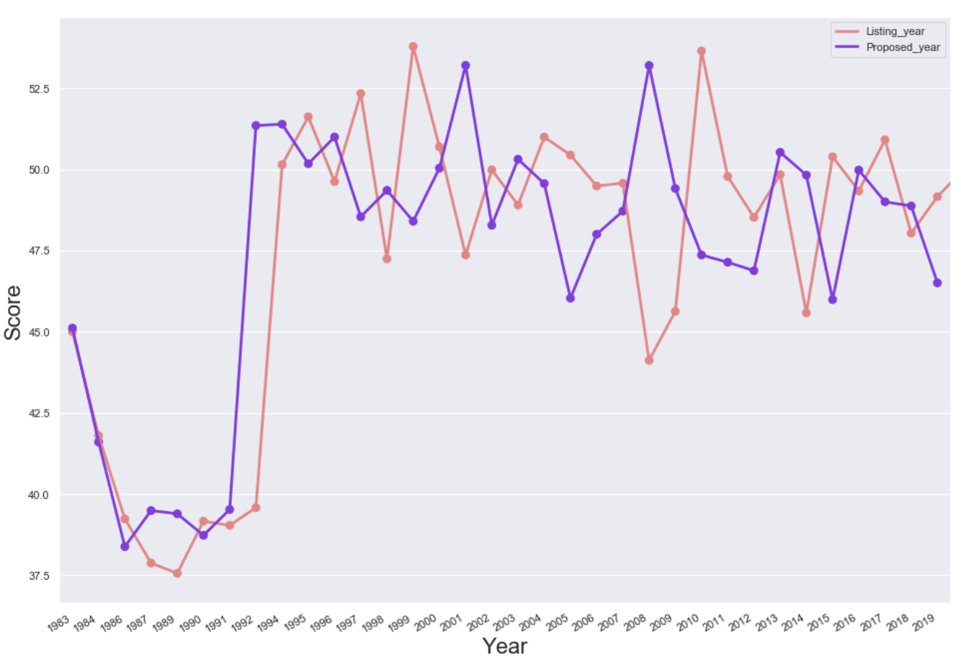

As can be seen from the graph, during the period from 1991 to 1993, the annual mean score increased significantly. So, there must have been some events that greatly influenced the score in these years.

1. In 1992, EPA enacted a new act, called the Environmental Protection Agency Act. The main purpose of this act is to control pollution, to set up the environmental protection agency and to fine those who violate it. (United States Environmental Protection Agency, “Environmental Protection Agency Act, 1992”)
2. Environmental protection agency mentioned above includes a program called Energy Star, which was also established in 1992. It is a voluntary labeling program to provide technical information and tools for organizations to find energy-efficient solutions. (Energy Star)
3. The last point is that EPA proposed guidelines for exposure assessment in 1992. The most important purpose of these guidelines is to provide guidelines for exposure to chemical substances, or exposure to harmful biological, noise agents. (United States Environmental Protection Agency, “Guidelines for Exposure Assessment (1992)”)

It is easy to see that these changes led to a significant increase in the average score of superfund's site during 1991 to 1993.

**Part four: (Integrated analysis of three data sets and prediction models of cancer cases)**

1. Exploratory Data Analysis

First, I am going to analyze data set of power plant and the data set of cancer rate together. I took the three states with the lowest number of cancer cases per 100,000 and the three states with the highest number of cancers cases, namely Kentucky, New York, Illinois, California, Texas and Colorado. I extracted data on power plants in these six states. Then I find the type of primary fuel, which accounts for the largest proportion in each state.

Before analyzing the data set, I also investigated the different types of fuel in the data set to help me understand which ones can increase the risk of getting cancer.

|  |  |
| --- | --- |
| Type of Fuel | Characteristics |
| Coal | Air pollution from coal-fired power plants poses a serious threat to human health. Of the 187 hazardous air pollutants identified by the U.S. Environmental Protection Agency, coal-fired power plants emitted 84. According to the National Toxicology Program, these pollutants may cause cancer. (Environmental Health & Engineering, Inc. 1-2) |
| Nuclear | Nuclear power plants may result in dangerous levels of radiation, which may cause threats to the health and safety of people who work or live near the plant. The emergency plan defines two areas near the nuclear power plant. In areas within 50 miles of plants, people may be exposed to radiation and be injured, which may cause serious illness or even death. (Ghirga) |
| Solar | 1.The electrical energy generated by solar panels is direct current, so the wires carrying direct current will not generate electromagnetic fields like the wires carrying alternating current. (The Solar Nerd)  2. Solar technology, meanwhile, not only won't cause cancer, it may even kill cancer cells (ANI). |
| Gas, Biomass, Oil | 1. There are several harmful emissions from burning gas, biomass and oil. To begin with, they will emit sulfur dioxide, nitrogen dioxide, and carbon monoxide, and they can cause cancer and other health problems. And these kinds of fuel will also emit particle pollution and ozone pollution (American Lung Association).  2. Gas and oil will emit Benzene, which is a well-established carcinogen with specific links to breast and urinary tract cancers, because Benzene will reduce the white and red blood cell production (ANI). |

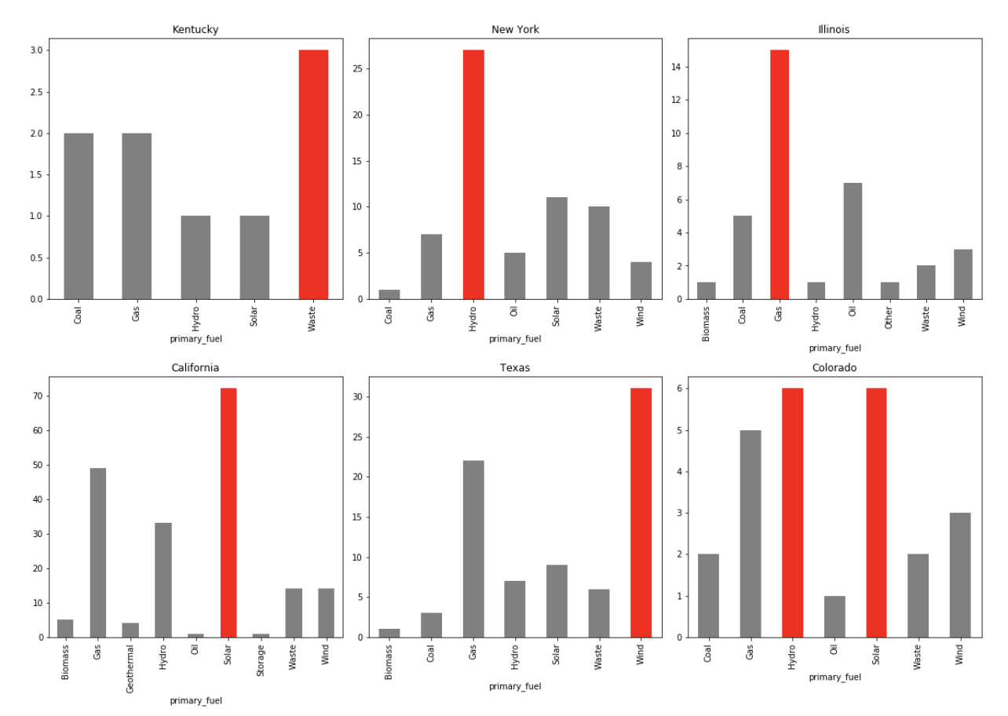

The first three states in the figure above are the three states with the highest average value of cancer cases per 100,000 people. It is not difficult to find that their main fuel types are waste, hydro and gas. Meanwhile, the number of power plants in Kentucky whose primary fuel is coal/gas is also very large.

These results are not surprisingly. For example, in Kentucky, renewable resources are a relatively small part of Kentucky's energy mix, and the state has no renewable energy standard, about one-tenth of the renewable generation in Kentucky, 0.6% of the state's total net generation. (Durkay)

In the following three states with the lowest average of cancer cases per 100,000 people, the primary fuel of their power plants mainly includes solar, wind, and solar.

This result seems to have some connection with the analysis of the effect of different fuels on cancer in the table above. It seems that the type of primary fuel used by the power plants in this state has a link to the mean value of cancer cases per 100000 people. Besides, clean energy sources like solar and wind may reduce the risk of cancer.

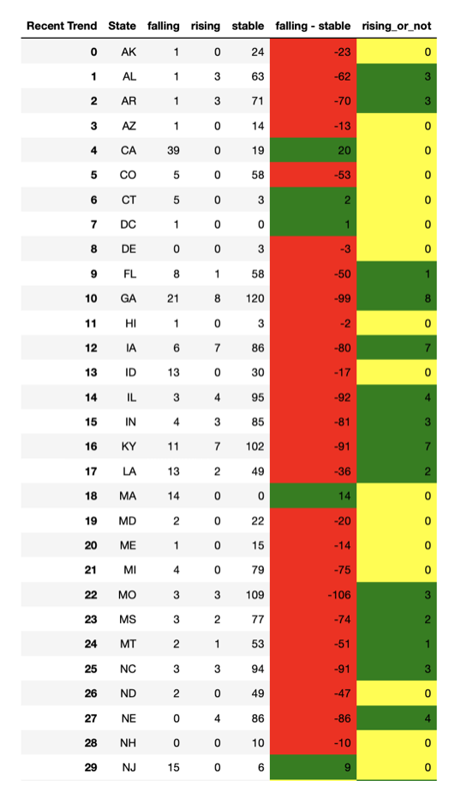

In part two, I once made this chart of the recent trend in different states in 5 years. From this chart’s second column, falling - stable, we can find that California, Massachusetts, and New Jersey have the largest value that is calculated by falling trend counties’ number minus stable trend counties’ number. So, I decided to draw the distribution of primary type of power plants in Massachusetts and New Jersey.

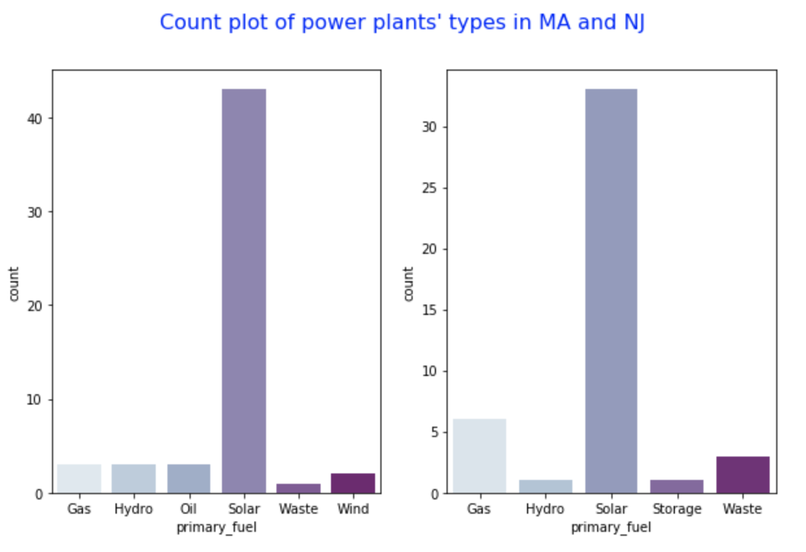

Then in Massachusetts and New Jersey, the fuel type of power plants is mainly solar, which is in accordance with the above analysis.

It's not hard to find out why there are so many solar power plants in California, Massachusetts and New Jersey by looking up materials on the Internet.

Over the last 20 years, California has the greatest number of world’s solar facilities. In 2005, California implemented the Energy Policy Act, which will provide tax credits for customers or business using clean energy. As a result, California's annual solar capacity reached 1868 megawatts in 2006. Under the leadership of Renewable Portfolio Standard, several large operating power plants in California underwent transformation in 2014, and their total annual power generation capacity reached 1900mw. (U.S. Energy Information) In the following year, in 2015, Apple and Google invested $850 million and $145 million respectively in solar power plants in California, all of which contributed to the rapid development of solar power plants in California.

As for New Jersey, the Public Service Enterprise Group of New Jersey announced plans to install solar panels on 200,000 utility poles as early as 2009, and this is the world's largest solar power project. (Borough of Magnolia)

Massachusetts has a similar program as mentioned above. The only difference is that there is an organization in Massachusetts called MassSolar, which will rethink the effect of last year's solar energy policy every year, which also promotes the progress of the solar industry in Massachusetts on the other hand. (Solarisworking)

At the same time, NJ and MA mentioned above have joined Grant Programs, which subsidize solar energy installation by organizations or private utilities(Energy policy in California)

For further analysis, I used Pearson coefficient below to determine the correlation between power plants’ primary fuel and cancer cases per 100000 people.

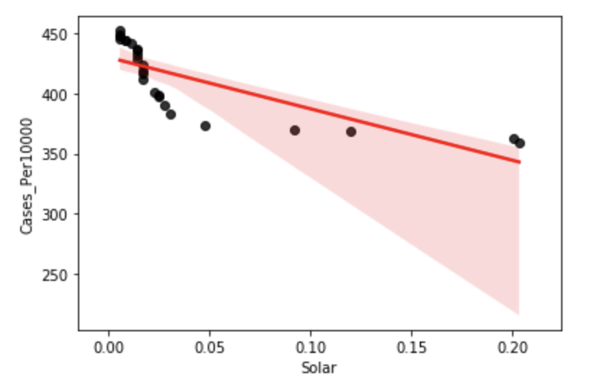

First, I selected the states with at least one primary fuel solar power plant. There are 25 such states in total. The horizontal axis in the figure above represents the proportion of primary fuel solar power plants in all power plants, while the vertical axis represents the average cancer cases per 100,000 people in this state.

It is not difficult to see a negative correlation from the figure. When I calculated a correlation using Pearson coefficient, I found that the Pearson efficient between them was -0.779, indicating a strong negative correlation.

Next, I continue to use Pearson coefficient method to analyze the relationship between coal and gas as the primary fuel and cancer cases per 100,000 people. The Pearson coefficient between mean cases and Gas is 0.8619, and the Pearson coefficient between mean cases and Coal is 0.955.

Finally, I decided to analyze the relationship between super fund sites’ scores and cancer cases. To facilitate the analysis, I changed the score into different bins with a difference of 10 between each interval.

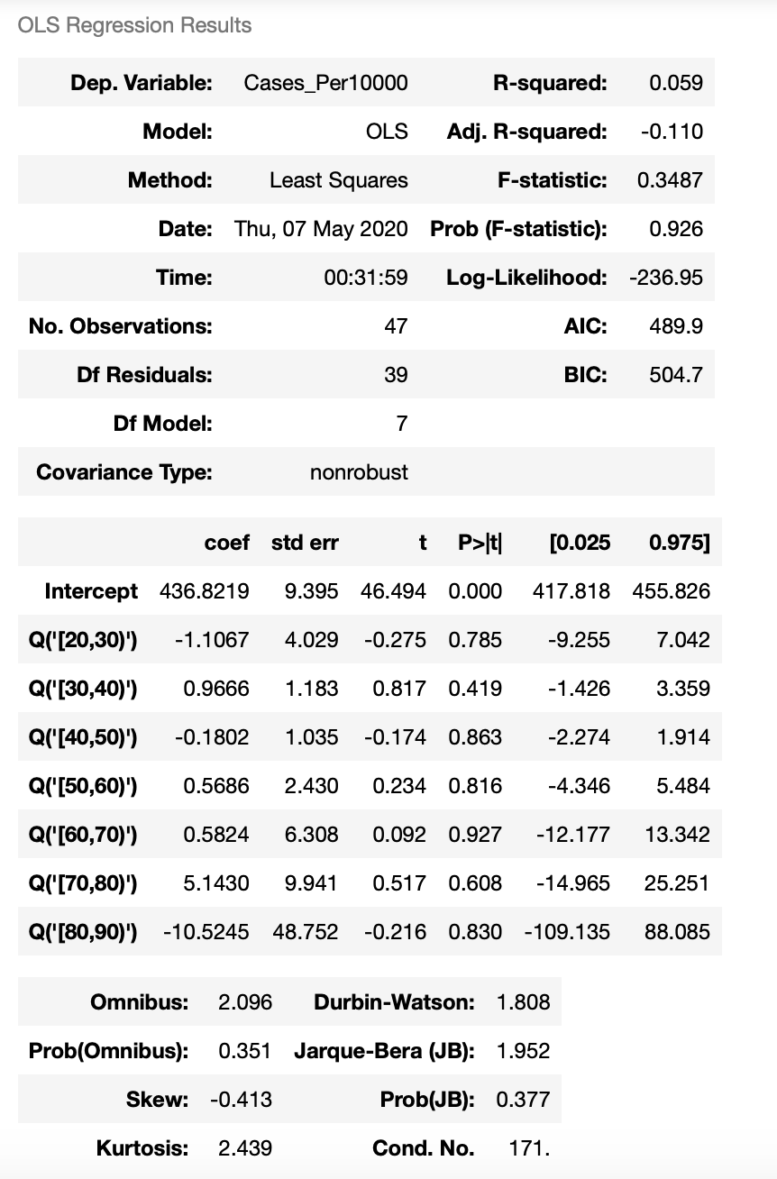

The F score is equal to 0.3487 and p value is 0.926. This tells us that there is no significant difference in the group means. Looking at P>|t| in the table, we can fine all variables are not statistically significant. Thus, score is not a useful feature to predict mean cancer cases.

1. Prediction Models

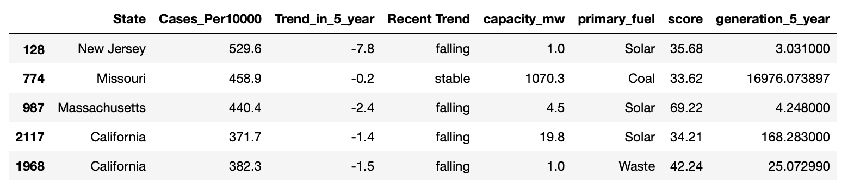

After combining three datasets and filtering the variables I did not use for predicting, the picture above is the features selected.

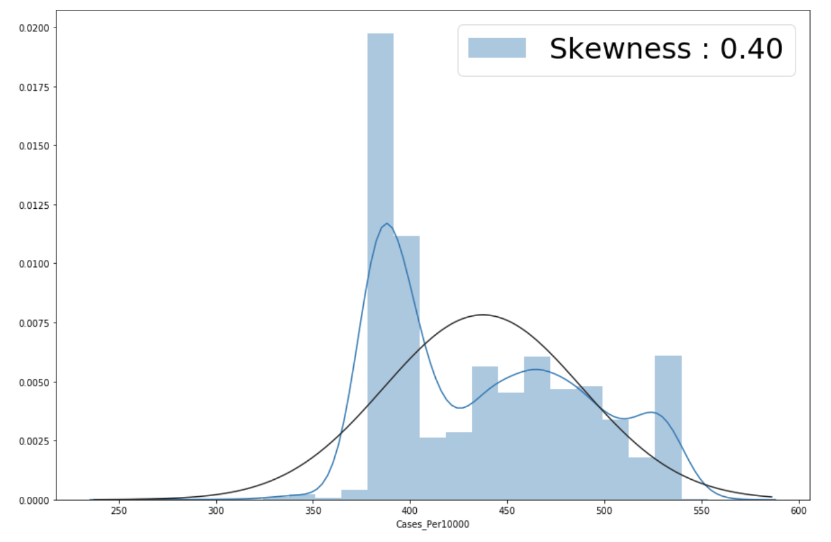

I make a graph to find the skewness of cancer cases per 100000 people, and the value is 0.40. It is less than 0.5 and larger than -0.5, so I do not need to make any transformation.

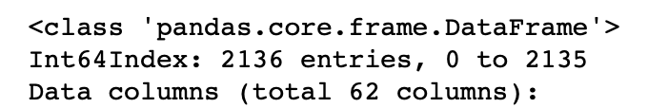

Because there are several categorical variables (like states, primary_fuel), I use pd.get_dummies to create new data frame with 62 columns.

When there are too many columns, the first way I came up with is PCA. However, after using PCA, I still need to select 46 components to obtain 90% variance. Therefore, I will use the data frame with 62 columns directly.

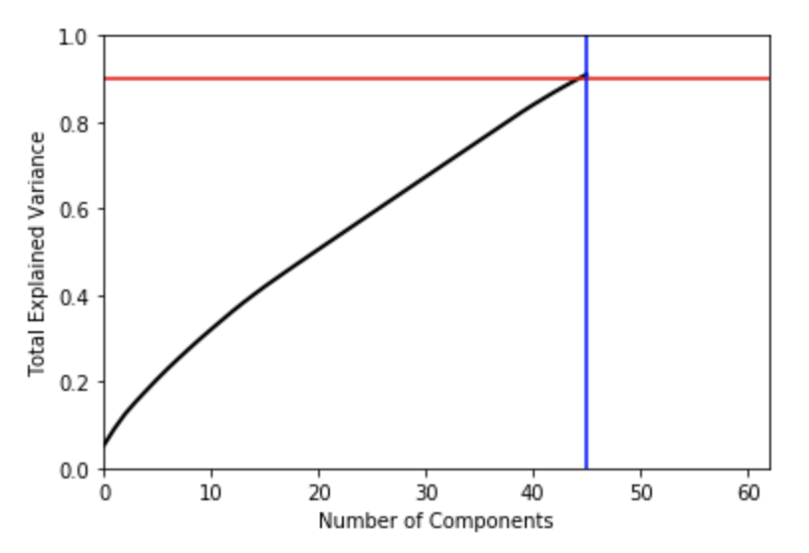

Before building several models, it is useful to get the baseline errors which is contained by using test dataset’s mean value to predict. And this baseline RMSE is 52.23.

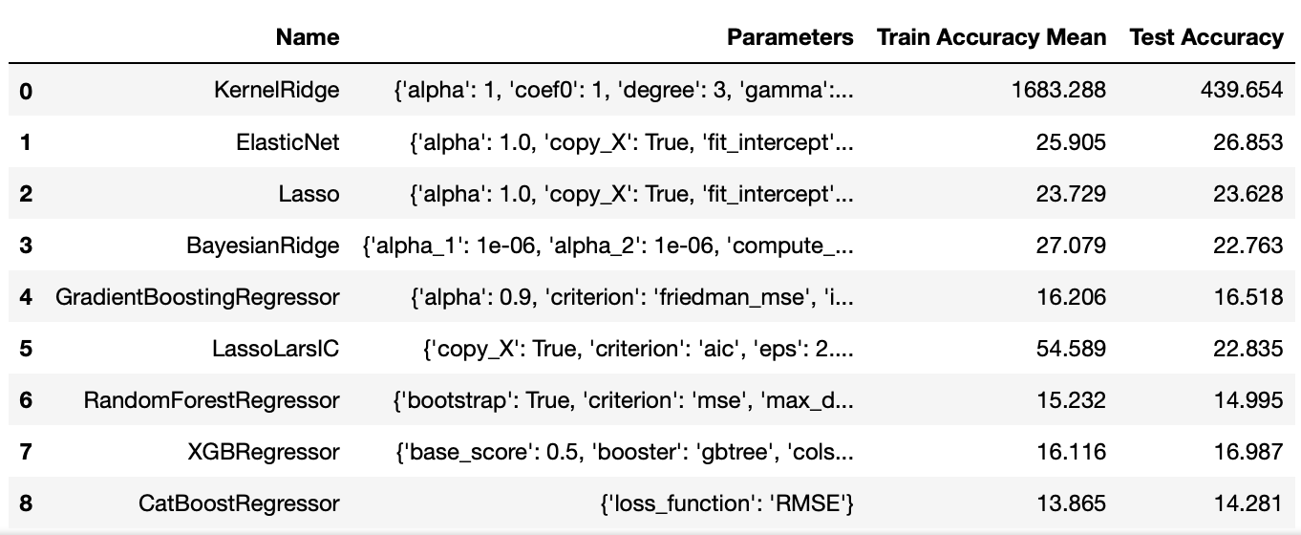

I have tried nine different models. The models with low RMSE are Lasso, GradientBoostingRegressor, RandomForestRegressor, XGBRegressor and CatBoostRegressor. So, in the next tuning parameter part, I will choose these models.

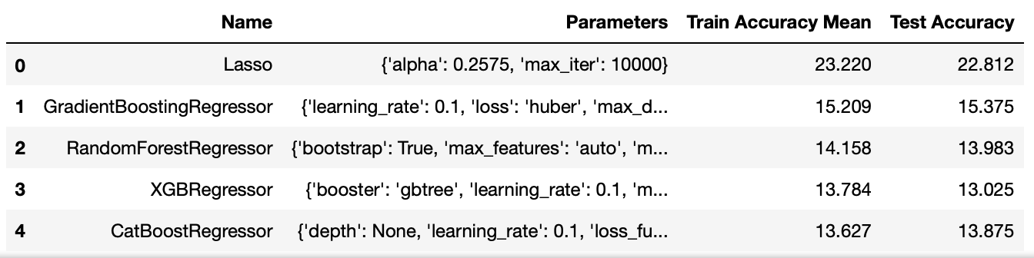

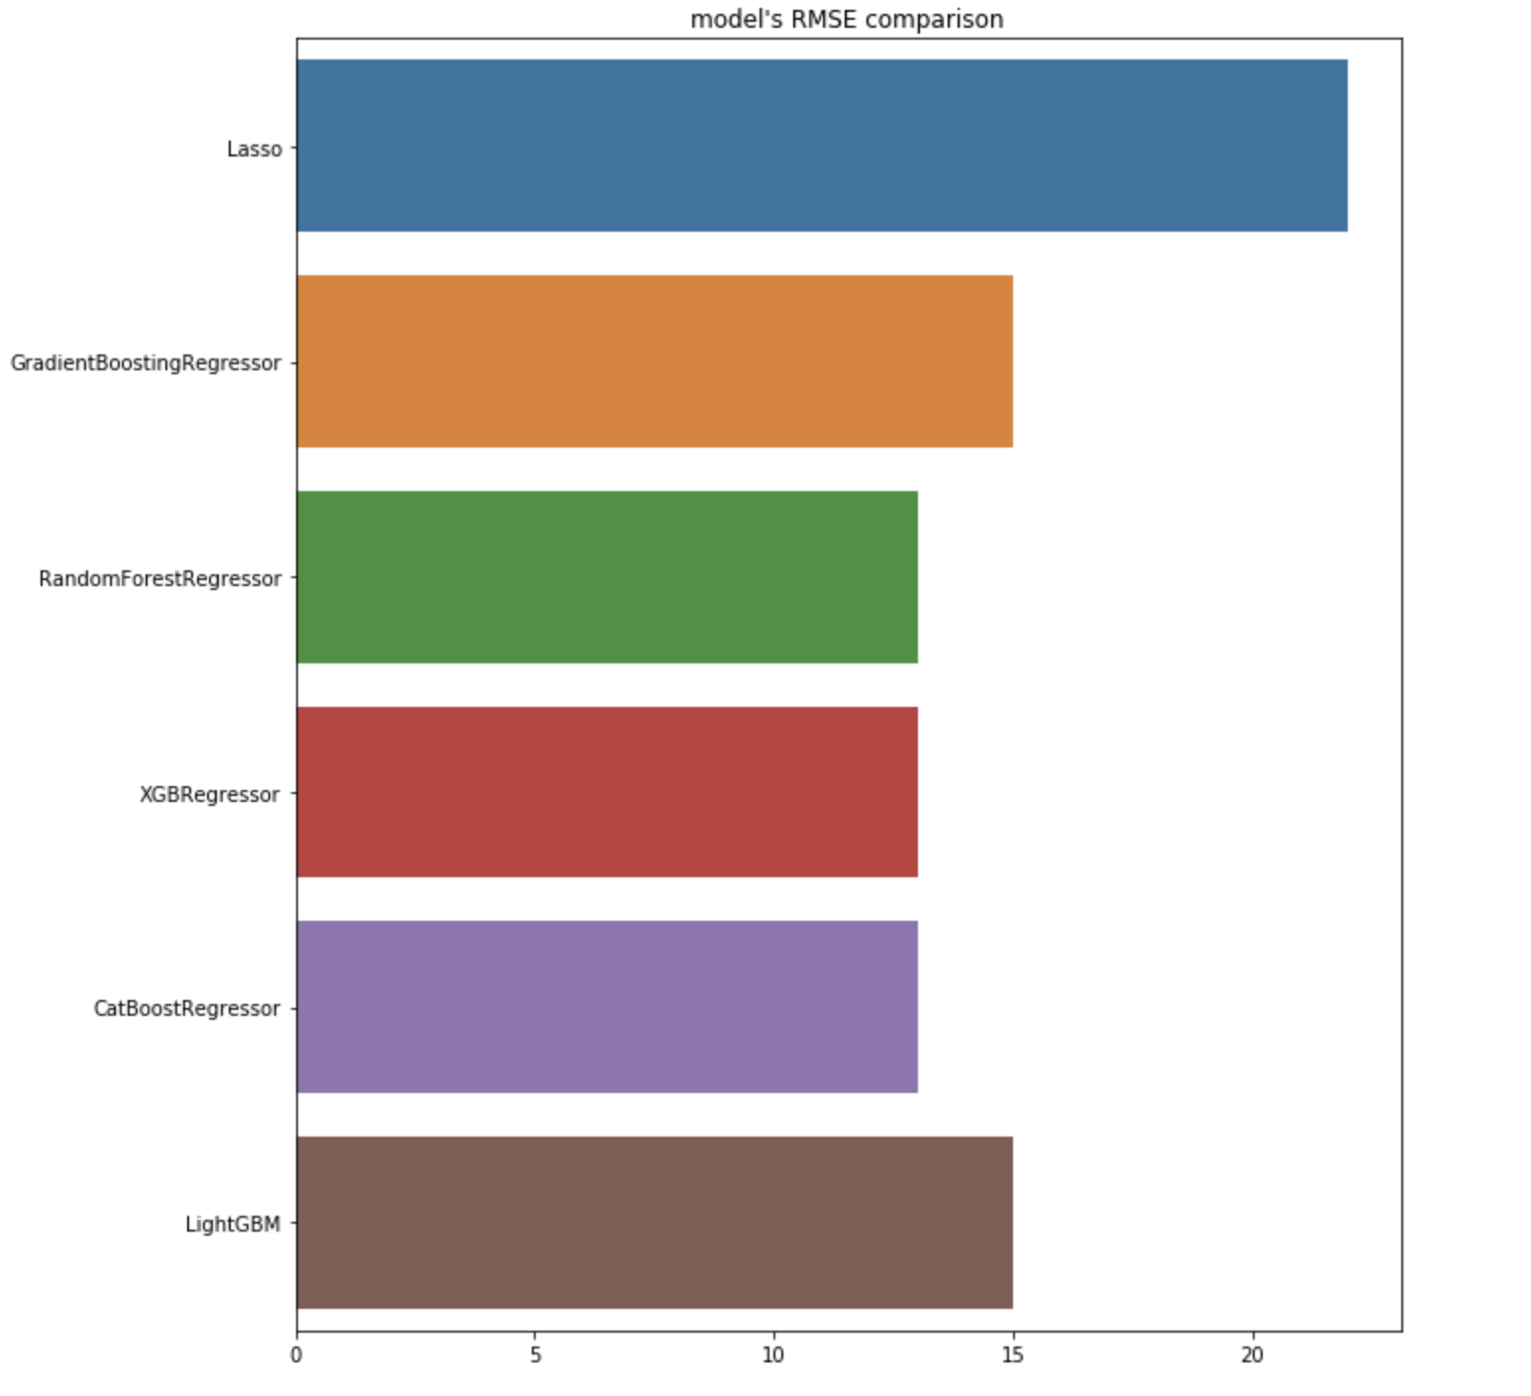

It is not difficult to find that all five models have lower test RMSE than the default models’ test RMSE, but Lasso still has relatively higher RMSE. So, I will drop it in the final model. Meanwhile, I still try LightGBM model, the test RMSE is 15.2247. Therefore, for the next step, I will use GradientBoostingRegressor, RandomForestRegressor, XGBRegressor, CatRegressor and LightGBM models.

For the last step, I will try two methods: Stacking and Blending.

The test RMSE of stacking model is 14.6762. But it is larger than RandomForestRegressor, XGBRegressor and CatBoostRegressor’s results.

The test RMSE of blending model is 13.078, which is the lowest value. The blending model is 0.7 * xgb_predict + 0.15 * cat_predict + 0.15 * rf_predict.

Because Dr. Ami does not allow us to use any other dataset, I will not be able to check the accuracy of my model in this report. Nevertheless, in the future, if I want to predict the cancer cases per 100000 people in any state, I will use this blending model with lowest RMSE to predict.

**Conclusion**

In today's society, one out of every six deaths is due to cancer, and cancer is the second leading cause of death, which has attracted increasing attention. Through the analysis of these data sets, I learned that the choice of the power plant energy is will influence for a number of cancer diagnosis, the more clean energy could effectively reduce the number of cancer, but surprisingly, when I will superfund sites score into 10 groups, after using one-way anova analysis, superfund sites score and the number of cancer is not much, I think this may be because the data set of superfund sites are all passed the HRS score of 28.5 points, It also proves that these sites meet high standards.

At the same time, whether or not superfund sites were sent for partial deletion and whether or not the federal took over is irrelevant to the HRS score of this site. The only thing most associated with score is time. This leads to the next conclusion that I can think of. With the development of time and the progress of society, people will pay more attention to health, the score of superfund sites will become higher and higher, and the popularity of clean energy such as solar energy will become higher and higher.

Such as mentioned above, California, in 2019 enacted numerous laws, such as Building Energy Efficiency Standards (BEES), incorporating solar into the state code and Standards, and customers over the use of solar Energy for help and compensation, the most important thing is to Reneables Portfolio Standard, The state requires 60% of California's energy to come from renewable sources by 2030 and 100% by 2045. For example, in Kentucky, which has a lot of coal power plants and gas power plants mentioned above, they will produce the largest solar power station in Kentucky in 2020.

Finally, I use the XGBoost CatBoost and RandomForest is forecasted, the RMSE is 13.078. But there is no doubt that still have a lot of variables affect the number of cancer, such as personal habits: smoking and drinking, and so on, such as per capita medical resources allocation and so on, all of these in the future can be analysis together, and this report to help me model is more accurate, will also be able to find what is the most important variable affecting the number of cancer, to help the government to further policy arrangements.

Works Cited

1. National Cancer Institute. “SEER Cancer Statistics Factsheets: Common Cancer Sites”. *SEER Cancer Statistics Review,* 1975–2017. National Cancer Institute: <https://seer.cancer.gov/statfacts/html/common.html>.

2. American Cancer Society. “Key Statistics for Cancers in Young Adults”. American Cancer Society. 8 Jan, 2020: <https://www.cancer.org/cancer/cancer-in-young-adults/key-statistics.html>

3. Piersol, Bill. “Why Are More Young Adults Getting Cancer? Obesity May Be to Blame”. Memorial Sloan Kettering Cancer Center. 30 May, 2019: <https://www.mskcc.org/blog/why-are-more-young-adults-getting-cancer-obesity-may-be-blame>

4. American Cancer Society. “The Value of Cancer Registries to the Public’s Health”. American Cancer Society. 2019: <https://www.fightcancer.org/sites/default/files/Value%20of%20Cancer%20Registries%20FINAL.pdf>

5. American Cancer Society. “Cancer Facts & Figures 2019”. American Cancer Society. 2019: <https://www.cancer.org/content/dam/cancer-org/research/cancer-facts-and-statistics/annual-cancer-facts-and-figures/2019/cancer-facts-and-figures-2019.pdf>

6. National Cancer Institute. “Interpretation of Incidence Rates Data: Incidence Rate Report for Florida by County”. National Cancer Institute. 2012-2016: https://statecancerprofiles.cancer.gov/incidencerates/index.php?stateFIPS=12&areatype=county&cancer=001&year=0&race=00&sex=0&age=157&type=incd&sortVariableName=rate&sortOrder=desc&output=2

7. Kirpal, Eshaan. “Global Power Plant Database”. 2019: <https://www.kaggle.com/eshaan90/global-power-plant-database#README.txt>

8. Loganbyers. “Global Power Plant Database”. 2020: <https://github.com/wri/global-power-plant-database>

9. United States Environmental Protection Agency. “Introduction to the Hazard Ranking System (HRS)”. United States Environmental Protection Agency: <https://www.epa.gov/superfund/introduction-hazard-ranking-system-hrs>

10. United States Environmental Protection Agency. “Facility Site Identification Data Standard”. United States Environmental Protection Agency. 6 Jan, 2016: <https://www.epa.gov/sites/production/files/2015-06/documents/facilitysite-v2a_10012014.pdf>

11. United States Environmental Protection Agency. “Notice of Policy Change for Partial Deletion from the NPL”. United States Environmental Protection Agency: <https://www.epa.gov/superfund/notice-policy-change-partial-deletion-npl>

12. United States Environmental Protection Agency. “Visiting a Regional Office”. United States Environmental Protection Agency: <https://www.epa.gov/aboutepa/visiting-regional-office>

13. United States Environmental Protection Agency. “Enforcement at Federal Facilities”. United States Environmental Protection Agency. <https://www.epa.gov/enforcement/enforcement-federal-facilities&ie=UTF-8&oe=UTF-8>

14. United States Environmental Protection Agency. “Comprehensive Environmental Response, Compensation, and Liability Act (CERCLA) and Federal Facilities”. United States Environmental Protection Agency: <https://www.epa.gov/enforcement/comprehensive-environmental-response-compensation-and-liability-act-cercla-and-federal>

15. United States Environmental Protection Agency. “Superfund Site Assessment Process”. United States Environmental Protection Agency: <https://www.epa.gov/superfund/superfund-site-assessment-process>

16. United States Environmental Protection Agency. “National Oil and Hazardous Substances Pollution Contingency Plan”. United States Environmental Protection Agency: <https://www.epa.gov/sites/production/files/2017-07/noipdtemplate07062017.docx>

17. United States Environmental Protection Agency. “Guidelines for Exposure Assessment (1992)”. United States Environmental Protection Agency. 1992: <https://cfpub.epa.gov/ncea/risk/recordisplay.cfm?deid=15263>

18. United States Environmental Protection Agency. “Environmental Protection Agency Act, 1992”. United States Environmental Protection Agency. 1992: <https://www.epa.ie/pubs/legislation/poe/EPA_legislation_epa_act_1992.pdf>

19. Energy Star. “History About Energy Star”. Energy Star: <https://www.energystar.gov/about/history-0>

20. Environmental Health & Engineering, Inc. “Emissions of Hazardous Air Pollutants from Coal-Fired Power Plants”. American Lung Association. 7 Mar, 2011: <https://www.lung.org/getmedia/25962184-d2fc-42f8-b5a3-8ece3257fbab/emissions-of-hazardous-air.pdf.pdf>

21. Ghirga, Giovanni. “Cancer in Children Residing Near Nuclear Power Plants: An Open Question”. *Italian Journal of Pediatrics*. US National Library of Medicine. 10 Sep, 2010: <https://www.ncbi.nlm.nih.gov/pmc/articles/PMC2944154/>

22. The Solar Nerd. “Do Solar Panels Cause Cancer?” The Solar Nerd. 12 Jul, 2019: https://www.thesolarnerd.com/blog/do-solar-panels-cause-cancer/

23. ANI. “Innovation: Solar Power technology may kill cancer cells”. Energyworld.com From The Economic Times. 27 Oct, 2019: <https://energy.economictimes.indiatimes.com/news/renewable/innovation-solar-power-technology-may-kill-cancer-cells/71782276>

24. American Lung Association. “Electric Utilities”. American Lung Association. 12 Feb, 2020: <https://www.lung.org/clean-air/outdoors/what-makes-air-unhealthy/electric-utilities>

25. "California: Renewables Portfolio Standard". Database of State Incentives for Renewables & Efficiency. October 7, 2015.

26. “U.S. Energy Information Administration - EIA - Independent Statistics and Analysis.” California First State to Generate More than 5% of Electricity from Utility-Scale Solar - Today in Energy - U.S. Energy Information Administration (EIA), 24 Mar. 2015, www.eia.gov/todayinenergy/detail.php?id=20492.

27. “Energy Policy in California.” Ballotpedia, ballotpedia.org/Energy_policy_in_California.

28. "PSE&G To Install 105 Pole Mounted Solar Panels in the Borough of Magnolia". Borough of Magnolia. March 6, 2010.

29. Solarisworking. “Solar Policy and Legislation.” MassSolar, 20 Sept. 2017, solarisworking.org/solar-policy-and-legislation.

30. Durkay, Jocelyn, State Renewable Portfolio Standards and Goals, National Conference of State Legislatures (February 1, 2019).